What is MongoDB?
MongoDB is an open-source, cross-platform, and distributed document-based database designed for ease of application development and scaling. It is a NoSQL database developed by MongoDB Inc.
MongoDB name is derived from the word "Humongous" which means huge, enormous. MongoDB database is built to store a huge amount of data and also perform fast.
MongoDB is not a Relational Database Management System (RDBMS). It's called a "NoSQL" database. It is opposite to SQL based databases where it does not normalize data under schemas and tables where every table has a fixed structure. Instead, it stores data in the collections as JSON based documents and does not enforce schemas. It does not have tables, rows, and columns as other SQL (RDBMS) databases.
The following table lists the relation between MongoDB and RDBMS terminologies.
MongoDB (NoSQL Database) | RDBMS (SQL Server, Oracle, etc.)
Database | Database
Collection | Table
Document | Row (Record)
Field | Column
In the RDBMS database, a table can have multiple rows and columns. Similarly in MongoDB, a collection can have multiple documents which are equivalent to the rows. Each document has multiple "fields" which are equivalent to the columns. Documents in a single collection can have different fields.
The following is an example of JSON based document.
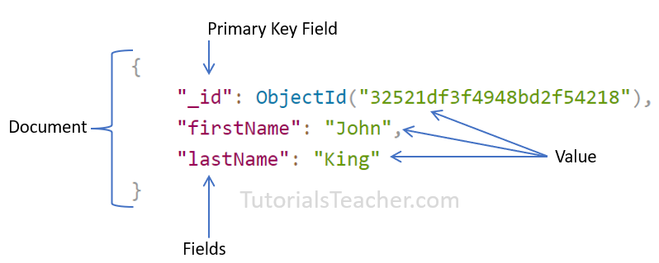MongoDB Document

Advantages of MongoDB
- MongoDB stores data as JSON based document that does not enforce the schema. It allows us to store hierarchical data in a document. This makes it easy to store and retrieve data in an efficient manner.
- It is easy to scale up or down as per the requirement since it is a document based database. MongoDB also allows us to split data across multiple servers.
- MongoDB provides rich features like indexing, aggregation, file store, etc.
- MongoDB performs fast with huge data.
- MongoDB provides drivers to store and fetch data from different applications developed in different technologies such as C#, Java, Python, Node.js, etc.
- MongoDB provides tools to manage MongoDB databases.

Install MongoDB Server, MongoDB Shell, Compass on Windows
Here you will learn how to install MongoDB server, MongoDB Shell, and compass on your local Windows machine.
Visit www.mongodb.com to download the MongoDB installer for your required platform.
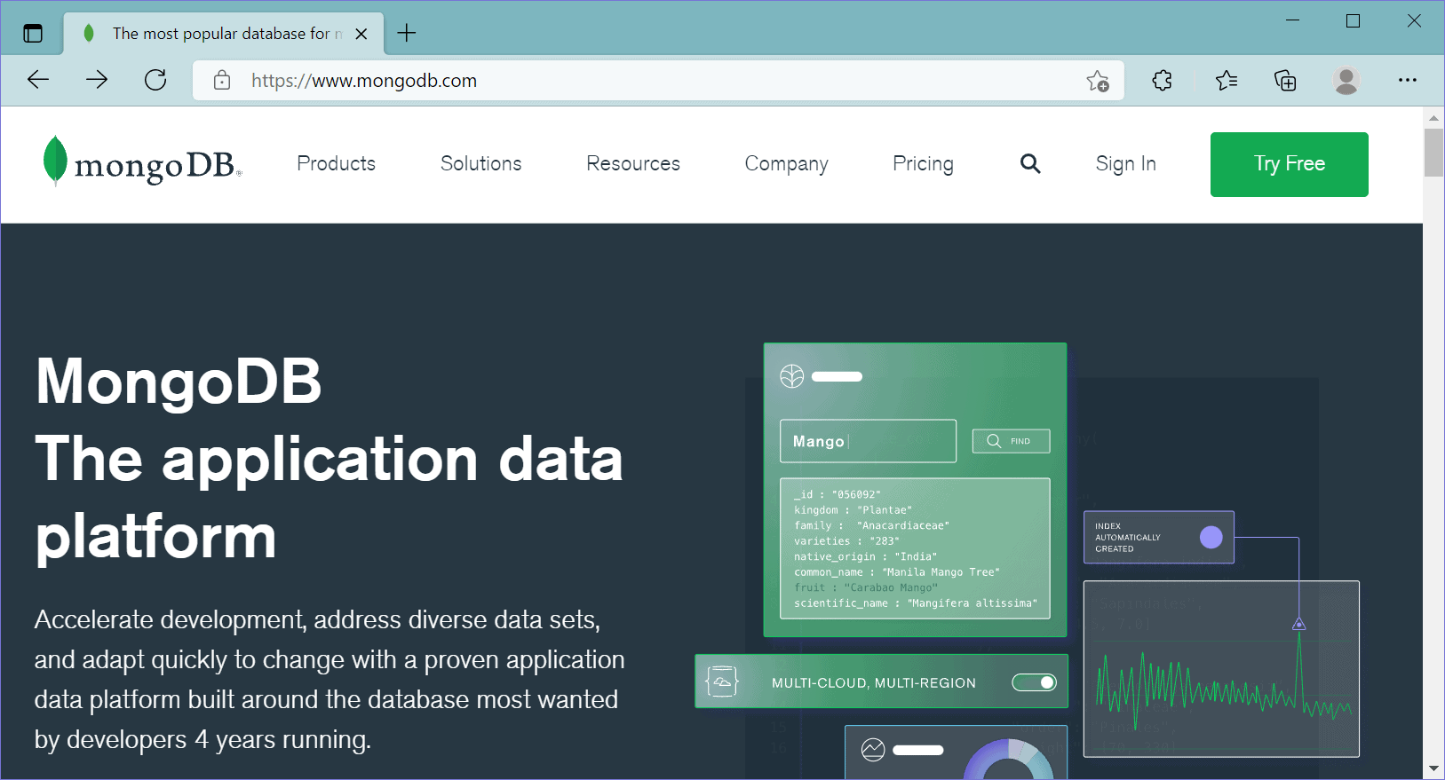MongoDB Official Website
Here, we are going to install a free MongoDB database server on our local Windows machine. So, click on the Product menu -> Community Server, as shown below.
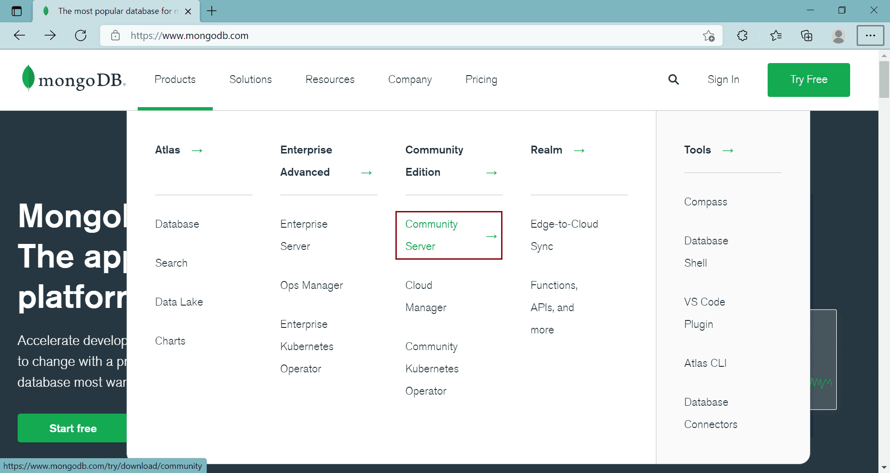MongoDB Community Edition
This will open a download page where you can select the version, platform, and package options.
Here, we will download the latest version of MongoDB, Windows platform, and msi file as a package, as shown below. Here, we will download the latest version of MongoDB, Windows platform, and msi file as a package, as shown below.
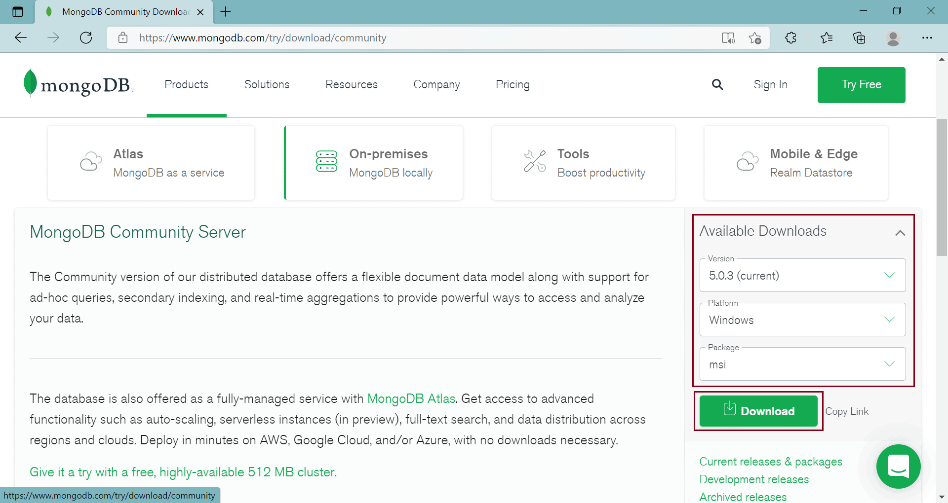Download MongoDB
Click on the Download button to download the installer file.
Once fully downloaded, click on the msi file to start the installation wizard, as shown below.
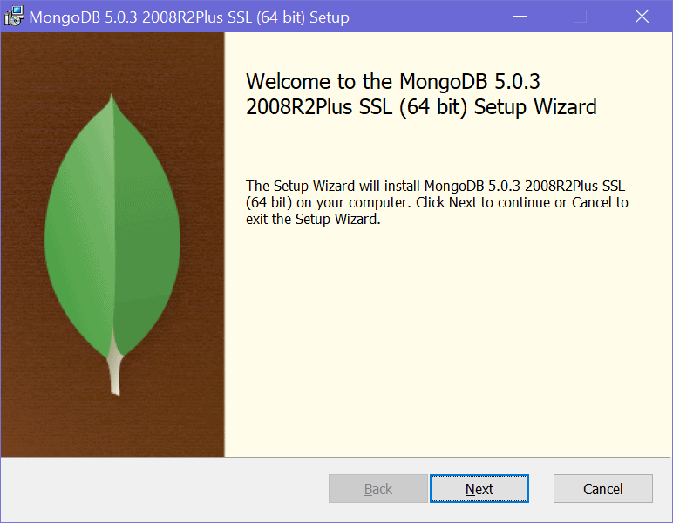
MongoDB Installation Wizard
Click Next to start the installation.
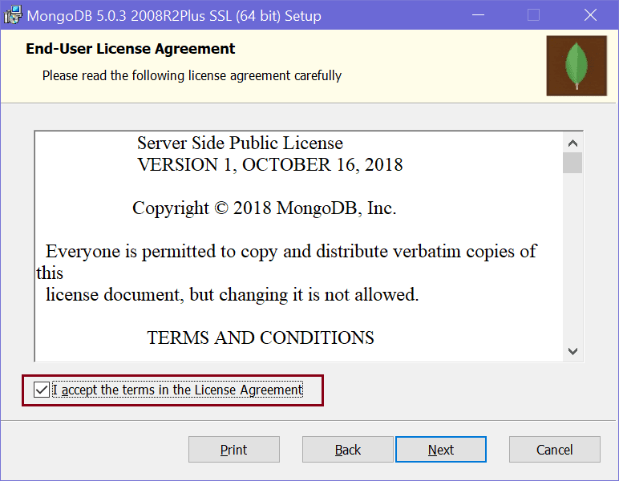
MongoDB Installation Wizard
Check the "I accept the terms in the License Agreement" checkbox and click Next.
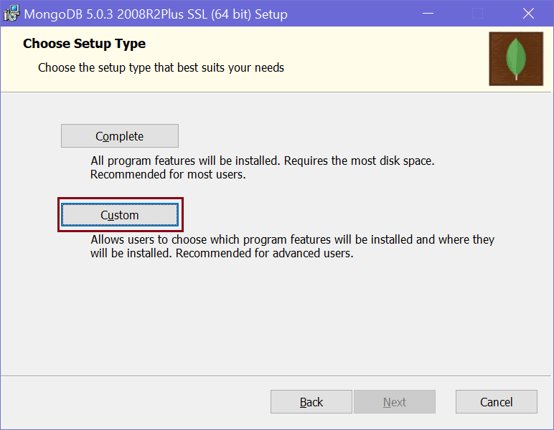
MongoDB Installation Wizard
Here, you will have two options for installation: Complete and Custom. The complete option will install all the features. The custom option allows you to select only required features.
You can select either of these two options. Here, we will select the custom option just to show you what all things it will install. So, click on the Custom option which will take you to the next step, as shown below.
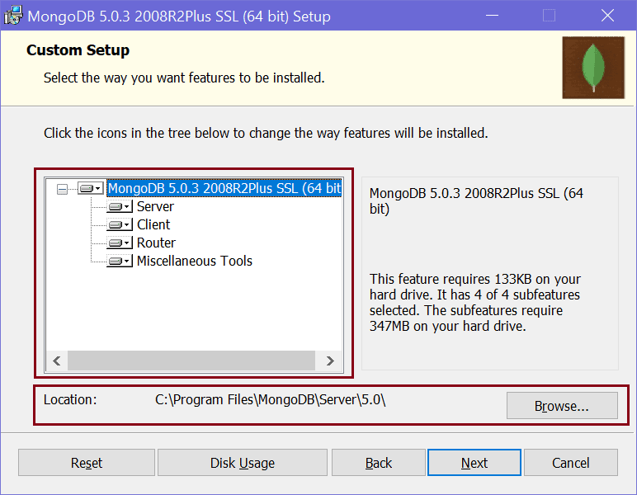
MongoDB Installation Wizard
In the custom setup page, expand the MongoDB node to see what all features will be installed. It will install Server, Client, Router, and Miscellaneous Tools for the MongoDB database. It also displays the location where the MongoDB is going to be installed. You may change it or keep the default location and click Next.
Click Next to configure the MongoDB service, as shown below.
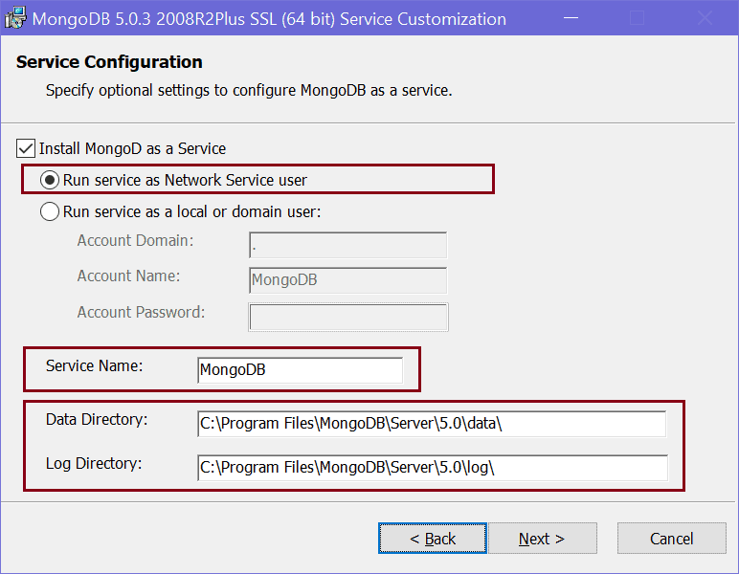
Configure MongoDB Service
MongoDB server will be installed as a service on your local Windows machine. As you can see above, you have an option to run a service as Network Service user or as a local or domain user. We will select "Run service as Network Service User" radio button.
You may change the default service name but it is recommended to keep the default "MongoDB" name to identify it easily.
MongoDB database stores the data as BSON files on your local machine. You can change the default location where the data files and log files are going to be stored. Here, we will keep the default paths and click the Next button.
On the next page, select "Install MongoDB Compass" checkbox and click Next. MongoDB Compass is a GUI tool for MongoDB database where you can visually explore data, run queries, and optimize performance.
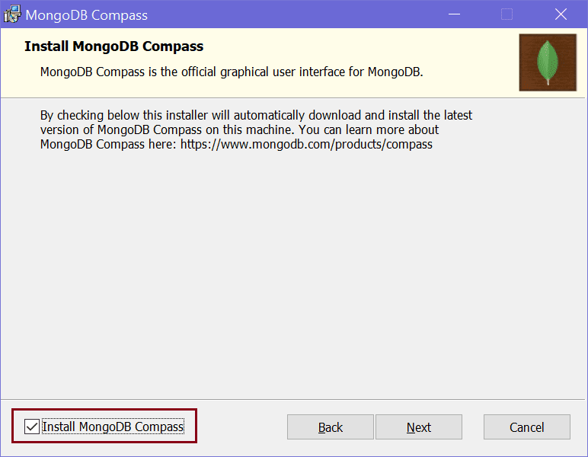
MongoDB Compass Installation
Next, click on the Install button to start the installation.
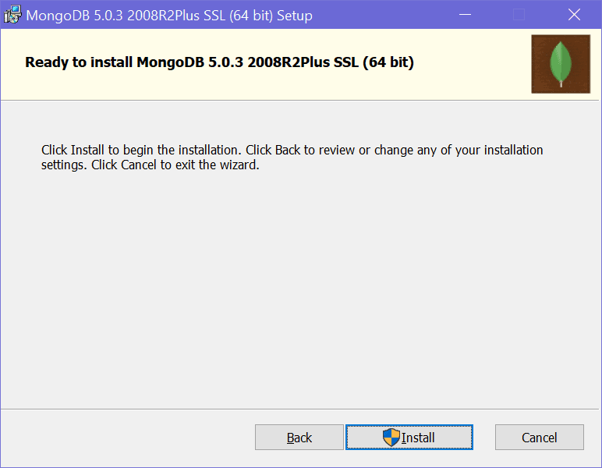
MongoDB Installation
It will take a few minutes to install. Once installed succefully, click on the Finish button to close the wizard.
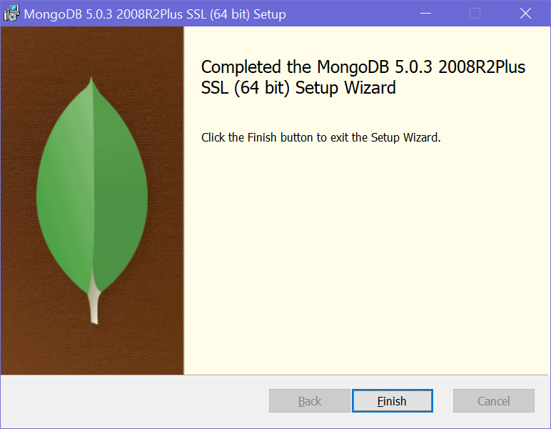
MongoDB Installation
It will also open MongoDB Compass, as shown below.
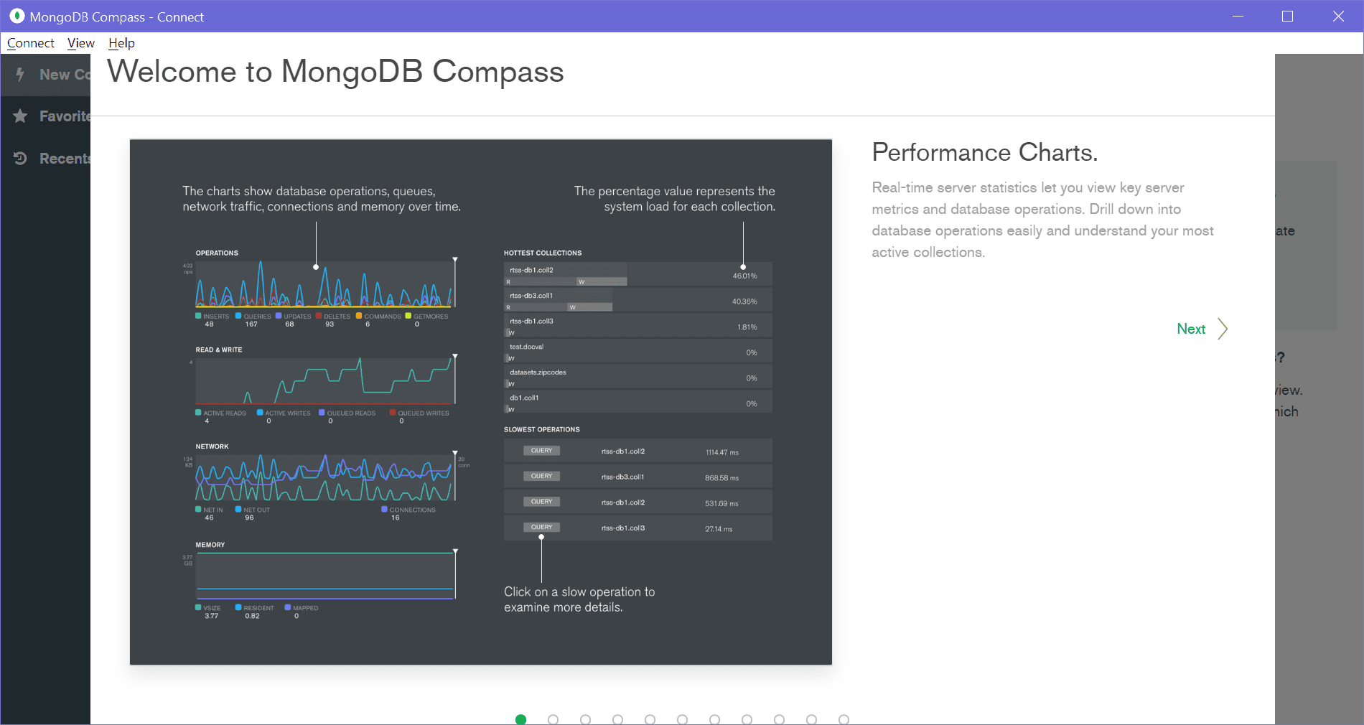
MongoDB Compass

MongoDB Server
We installed MongoDB as a Network service. To see this, open Services by searching "service" in the windows search box and click on the Services app, as shown below.
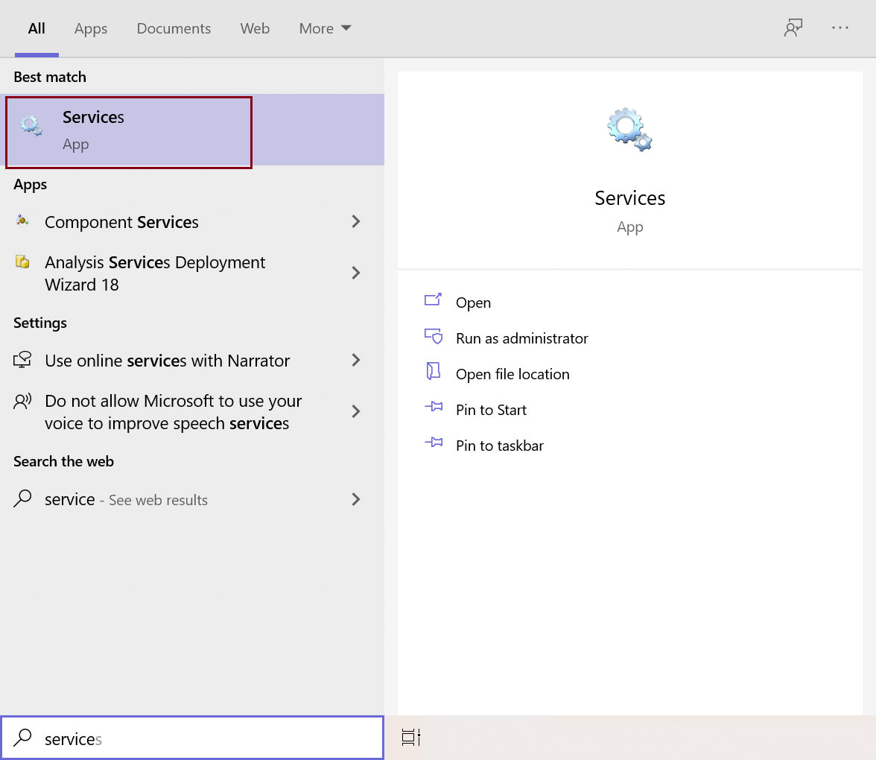MongoDB Service
On the Services window, navigate to MongoDB Server, as shown below. You will find that it is already up and running.
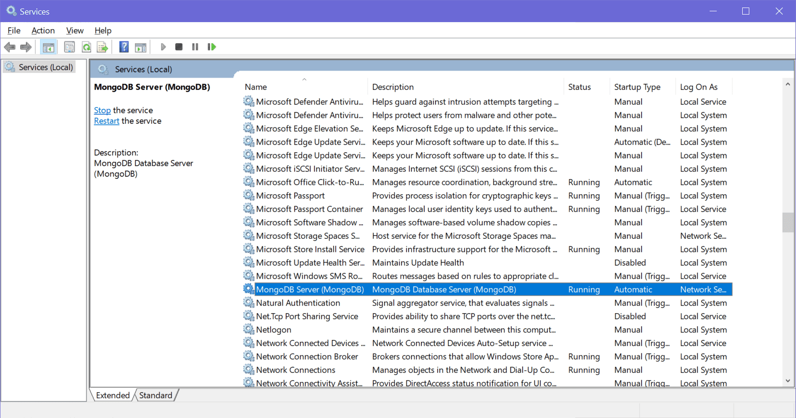MongoDB Service on Windows
Now, the MongoDB Server service is already running, you can connect the MongoDB client to connect with this MongoDB server and execute the commands.

MongoDB Client
MongoDB clients can be your application, MongoDB Shell, MongoDB Compass, or anything which wants to connect and store data to the MongoDB server.
Here, we already installed two clients, MongoDB Shell and MongoDB Compass.
Go to the path where MongoDB was installed. By default it is "C:\Program Files\MongoDB\Server\5.0\bin", as shown below.
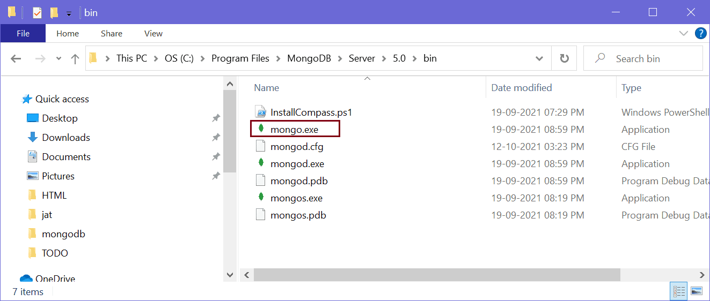MongoDB Installation Folder
Here, you will find mongo.exe, which is MongoDB Shell. Click on mongo.exe to start the client, as shown below.
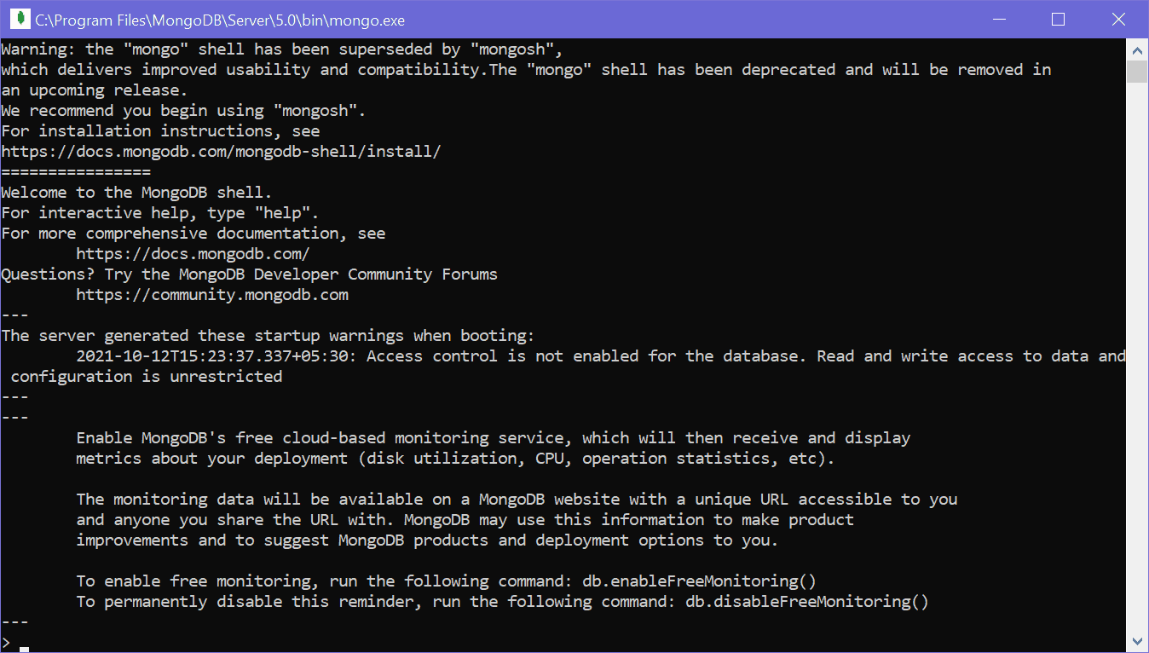MongoDB Shell
You can execute the commands here. For example, write "show dbs" and press Enter to display the database it already has, as shown below.
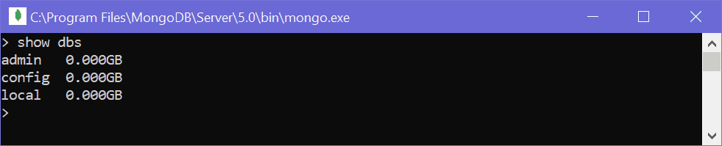MongoDB Shell Command
Thus, you can install the MongoDB server, clients (MongoDB Shell and Compass), and other features.

MongoDB Server - mongod, Configurations
Here you will learn what is MongoDB server, how to run it manually, and how to set various configuration settings for your MongoDB server.
We installed the MongoDB server as a Windows service in the Install MongoDB chapter. MongoDB windows service is automatically up and running at startup, as shown below.
MongoDB Service on Windows
Internally, the MongoDB service starts the local MongoDB server at the default address http://127.0.0.1:27017 whenever your machine starts. MongoDB server is installed as mongod.exe on Windows in the {mongodb install folder}/bin folder, as shown below.
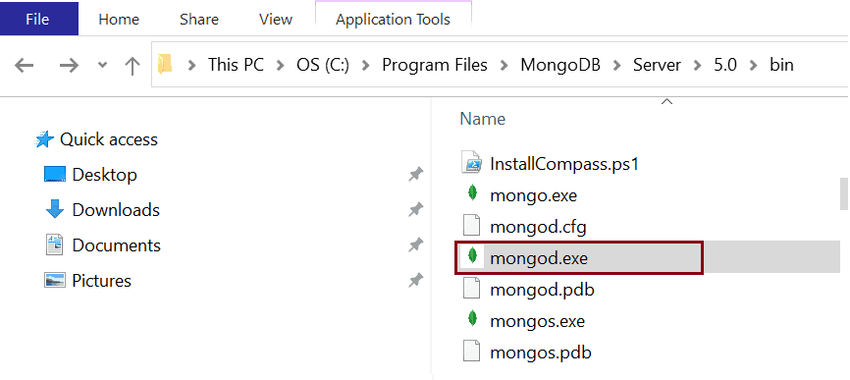MongoDB Server File - mongod.exe
The MongoDB server mongod can be started or stop manually whether you installed it as a service or not.

Run mongod Manually
If you have installed MongoDB as a windows service then stop the service first as we are going to start it manually.
Now, add {mongodb install folder}/bin to your environment variable on your local Windows machine. Search for "Environment" on windows search and click "Edit the system environment variable" to open system properties, as shown below.
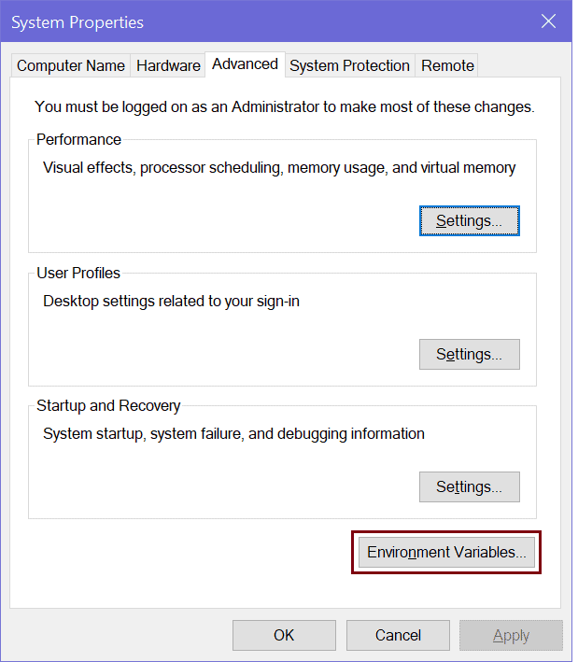System Properties
Click on "Environment Variables.." to edit path, as shown below.
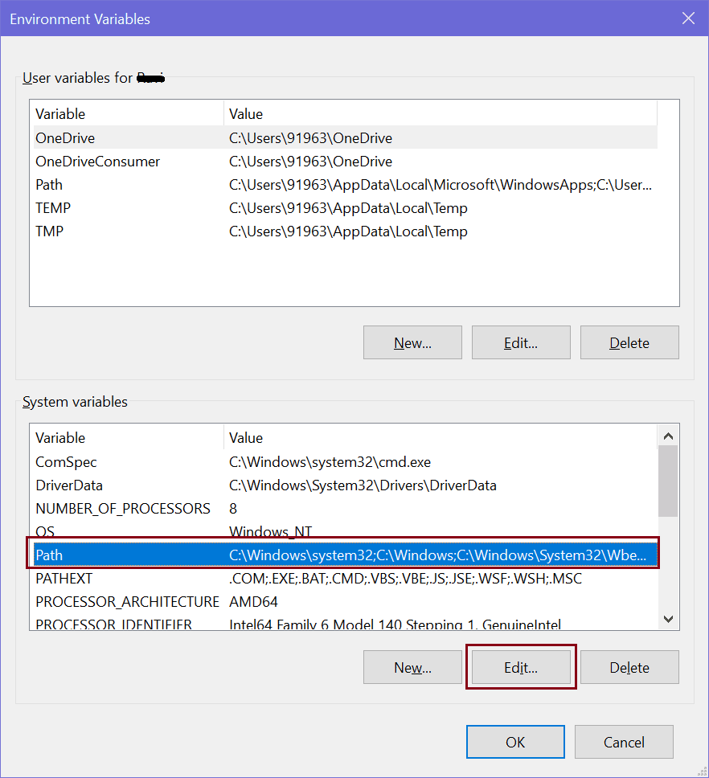Environment Variable - Path
Now, select Path in the bottom pane and click on the Edit button. This will open "Edit environment variable" window. Click on the New button to add MongoDB folder path "C:\Program Files\MongoDB\Server\5.0\bin\", as shown below.
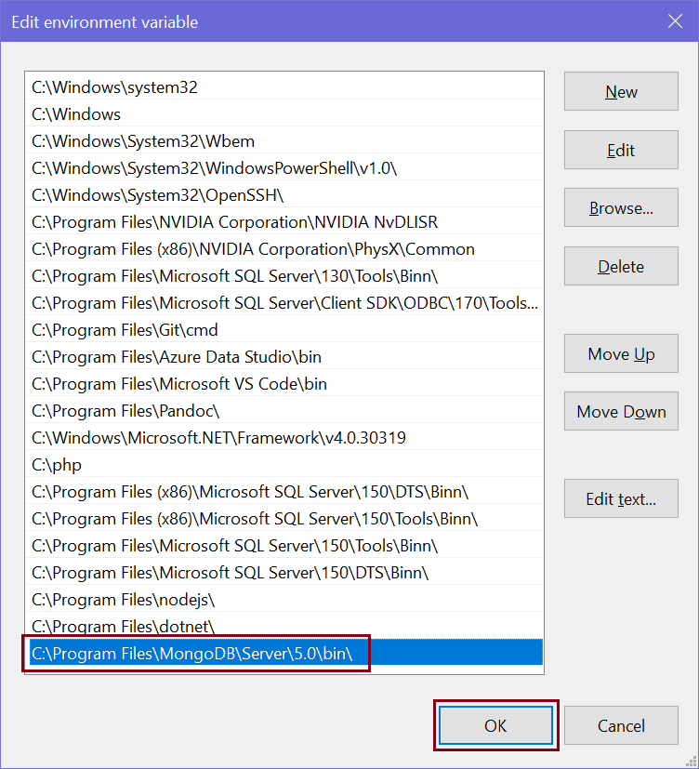Add MongoDB Folder Path
Click OK to close all pop-up windows.
Adding MongoDB folder path to environment variable allow us to run mongod.exe from anywhere on command prompt/terminal.
Now, open a command prompt on Windows or terminal as an administrator and execute the mongod on Windows or sudo mongod on Mac to run your MongoDB server, as shown below.
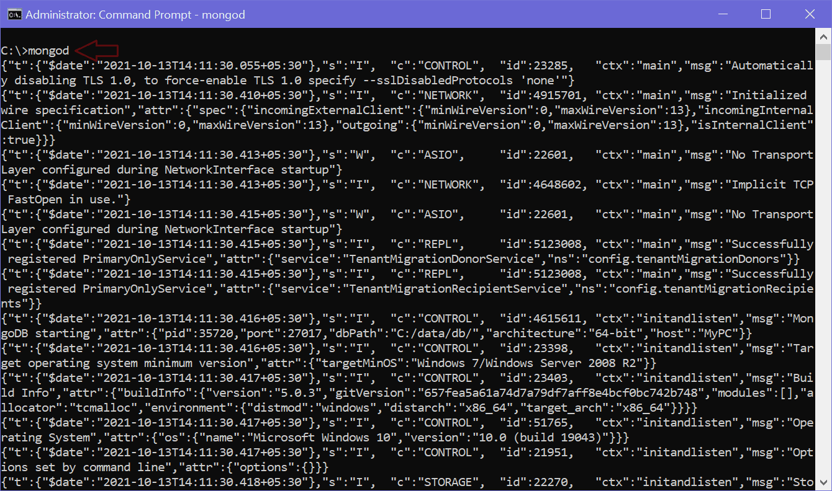Start MongoDB Server
You can specify various command options with mongod command for testing purposes. The following is list of some useful command options.
-h [ --help ] Show this usage information
--version Show version information
-f [ --config ] arg Configuration file specifying
additional options
--configExpand arg Process expansion directives in config
file (none, exec, rest)
--port arg Specify port number - 27017 by default
--ipv6 Enable IPv6 support (disabled by
default)
--listenBacklog arg (=2147483647) Set socket listen backlog size
--maxConns arg (=1000000) Max number of simultaneous connections
--pidfilepath arg Full path to pidfile (if not set, no
pidfile is created)
--timeZoneInfo arg Full path to time zone info directory,
e.g. /usr/share/zoneinfo
-v [ --verbose ] [=arg(=v)] Be more verbose (include multiple times
for more verbosity e.g. -vvvvv)
--quiet Quieter output
--logpath arg Log file to send write to instead of
stdout - has to be a file, not
directory
--logappend Append to logpath instead of
over-writing
--logRotate arg Set the log rotation behavior
(rename|reopen)
--timeStampFormat arg Desired format for timestamps in log
messages. One of iso8601-utc or
iso8601-local
--setParameter arg Set a configurable parameter
--bind_ip arg Comma separated list of ip addresses to
listen on - localhost by default
--bind_ip_all Bind to all ip addresses
--noauth Run without security
--transitionToAuth For rolling access control upgrade.
Attempt to authenticate over outgoing
connections and proceed regardless of
success. Accept incoming connections
with or without authentication.
--slowms arg (=100) Value of slow for profile and console
log
--slowOpSampleRate arg (=1) Fraction of slow ops to include in the
profile and console log
--profileFilter arg Query predicate to control which
operations are logged and profiled
--auth Run with security
--clusterIpSourceAllowlist arg Network CIDR specification of permitted
origin for `__system` access
--profile arg 0=off 1=slow, 2=all
--cpu Periodically show cpu and iowait
utilization
--sysinfo Print some diagnostic system
information
--noscripting Disable scripting engine
--notablescan Do not allow table scans
--keyFile arg Private key for cluster authentication
--clusterAuthMode arg Authentication mode used for cluster
authentication. Alternatives are
(keyFile|sendKeyFile|sendX509|x509)

Replication options:
--oplogSize arg Size to use (in MB) for replication op
log. default is 5% of disk space (i.e.
large is good)

Replica set options:
--replSet arg arg is [/]
--enableMajorityReadConcern [=arg(=1)] (=1)
Enables majority readConcern.
enableMajorityReadConcern=false is no
longer supported

Sharding options:
--configsvr Declare this is a config db of a
cluster; default port 27019; default
dir /data/configdb
--shardsvr Declare this is a shard db of a
cluster; default port 27018

Storage options:
--storageEngine arg What storage engine to use - defaults
to wiredTiger if no data files present
--dbpath arg Directory for datafiles - defaults to
\data\db\ which is C:\data\db\ based on
the current working drive
--directoryperdb Each database will be stored in a
separate directory
--syncdelay arg (=60) Seconds between disk syncs
--journalCommitInterval arg (=100) how often to group/batch commit (ms)
--upgrade Upgrade db if needed
--repair Run repair on all dbs
--journal Enable journaling
--nojournal Disable journaling (journaling is on by
default for 64 bit)
--oplogMinRetentionHours arg (=0) Minimum number of hours to preserve in
the oplog. Default is 0 (turned off).
Fractions are allowed (e.g. 1.5 hours)

Free Monitoring Options:
--enableFreeMonitoring arg Enable Cloud Free Monitoring
(on|runtime|off)
--freeMonitoringTag arg Cloud Free Monitoring Tags

Windows Service Control Manager options:
--install Install Windows service
--remove Remove Windows service
--reinstall Reinstall Windows service (equivalent
to --remove followed by --install)
--serviceName arg Windows service name
--serviceDisplayName arg Windows service display name
--serviceDescription arg Windows service description
--serviceUser arg Account for service execution
--servicePassword arg Password used to authenticate
serviceUser

WiredTiger options:
--wiredTigerCacheSizeGB arg Maximum amount of memory to allocate
for cache; Defaults to 1/2 of physical
RAM
--zstdDefaultCompressionLevel arg (=6)
Default compression level for zstandard
compressor
--wiredTigerJournalCompressor arg (=snappy)
Use a compressor for log records
[none|snappy|zlib|zstd]
--wiredTigerDirectoryForIndexes Put indexes and data in different
directories
--wiredTigerCollectionBlockCompressor arg (=snappy)
Block compression algorithm for
collection data [none|snappy|zlib|zstd]
--wiredTigerIndexPrefixCompression arg (=1)
Use prefix compression on row-store
leaf pages

MongoDB Server Configuration
MongoDB uses the configuration file options to control the behavior of a database. MongoDB server mongod runs with the default configurations added in the config file. On Windows, it is {install directory}\bin\mongod.cfg file. On MacOS, it is /usr/local/etc/mongod.conf or /opt/homebrew/etc/mongod.conf. And, on Linux, it is /etc/mongod.conf file. MongoDB configuration files use the YAML format. The following is the mongod.cfg file on Windows:
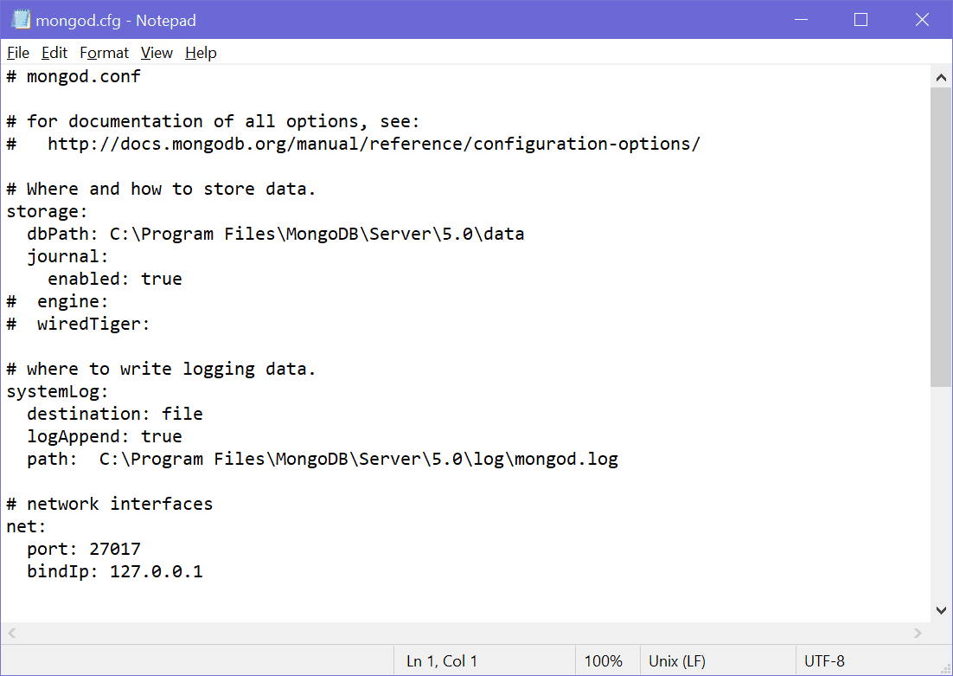mongod.cfg
The following is the sample config file which you may like to use for your local mongod server.
systemLog:
destination: file
path: "/var/log/mongodb/mongod.log"
logAppend: true
storage:
journal:
enabled: true
processManagement:
fork: true
net:
bindIp: 127.0.0.1
port: 27017
setParameter:
enableLocalhostAuthBypass: false

MongoDB Shell
MongoDB Shell is the quickest way to connect, configure, query, and work with your MongoDB database. It acts as a command-line client of the MongoDB server.
The MongoDB Shell is a standalone, open-source product and developed separately from the MongoDB Server under the Apache 2 license. It is a fully functional JavaScript and Node.js 14.x REPL for interacting with MongoDB servers.
MongoDB Shell is already installed with MongoDB. You can find it in the installation directory where you installed MongoDB. By default, it is "C:\Program Files\MongoDB\Server". Open the installation folder and appropriate version folder and go to the "bin" folder. Here, "mongo.exe" is MongoDB shell. Click on it to open the MongoDB shell, as shown below.


New MongoDB Shell - mongosh
In the installation folder, if you find mongosh.exe instead of mongo.exe then you already have a new MongoDB shell. If you don't find it, then you need to install it separately.
The new MongoDB Shell mongosh has some more features than old shell mongo such as intelligent autocomplete and syntax highlighting, easy to understand error messages, formatting feature to present the output in a readable format, etc. However, all the commands will be executed in mongosh as well as mongo shell.

Install mongosh
To install the new MongoDB shell (mongosh), visit www.mongodb.com and click on Product menu -> Tools -> Database Shell, as shown below.
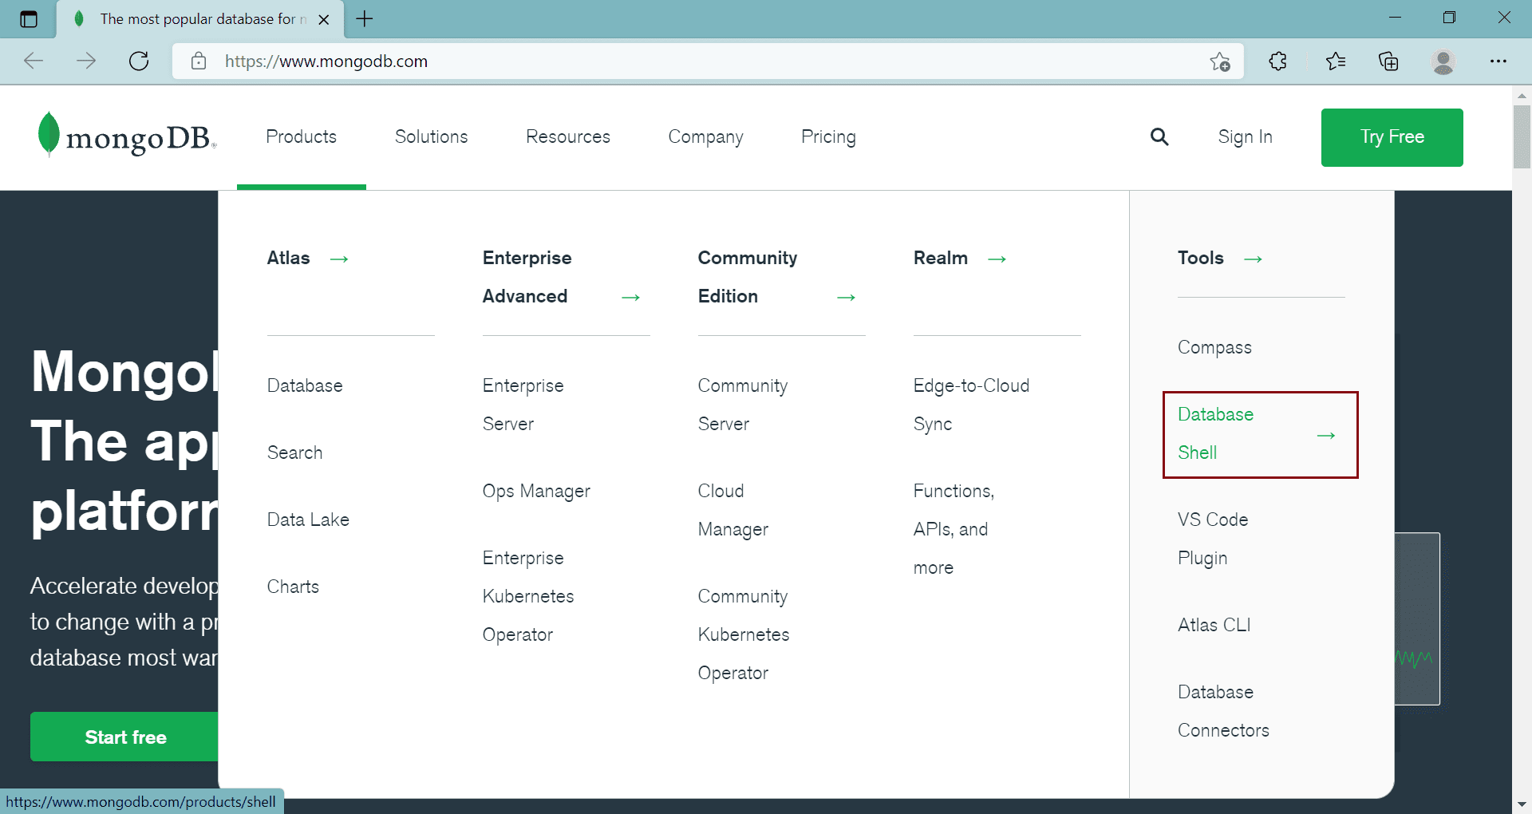Download New MongoDB Shell
On the MongoDB Shell page, click on the Download button to download the shell.
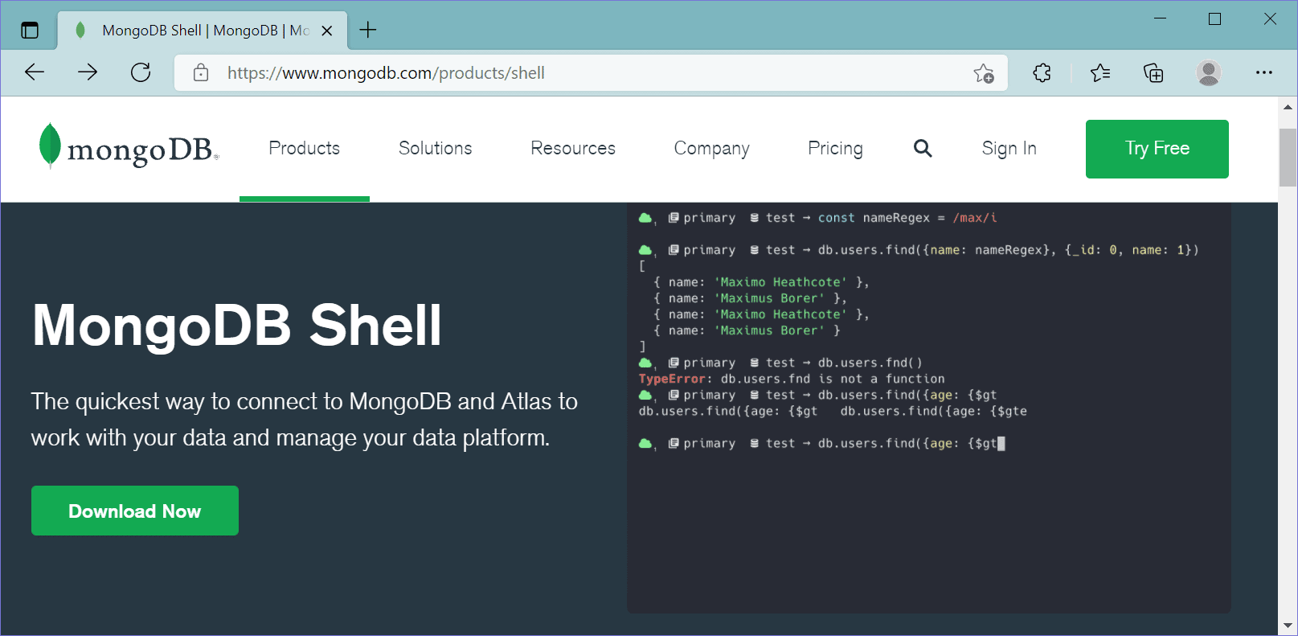Download New MongoDB Shell
This will take you to a page where you can select a version, platform, and package to download, as shown below.
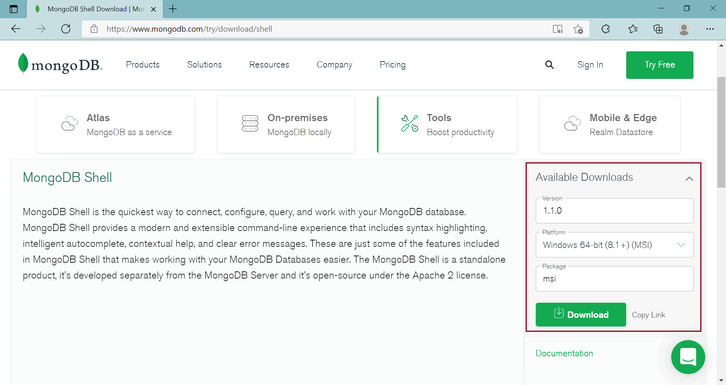Download New MongoDB Shell
Click on the Download button to download the installer file.
Now, click on the downloaded installer file to start the installation wizard, as shown below.
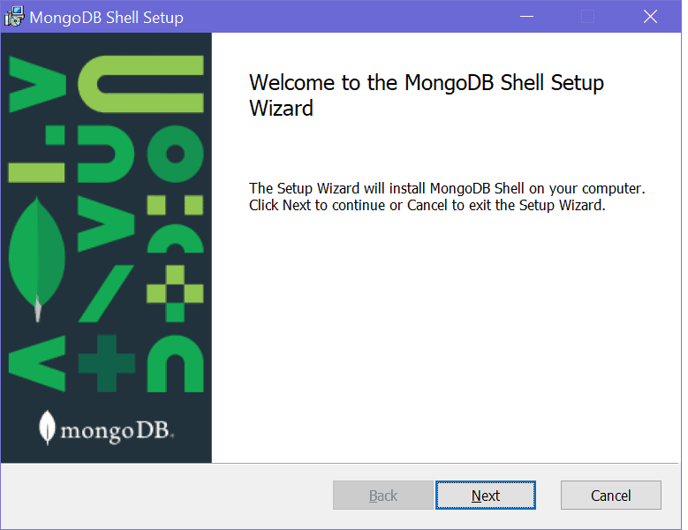Install New MongoDB Shell - mongosh
Click Next to go to next step shown below.
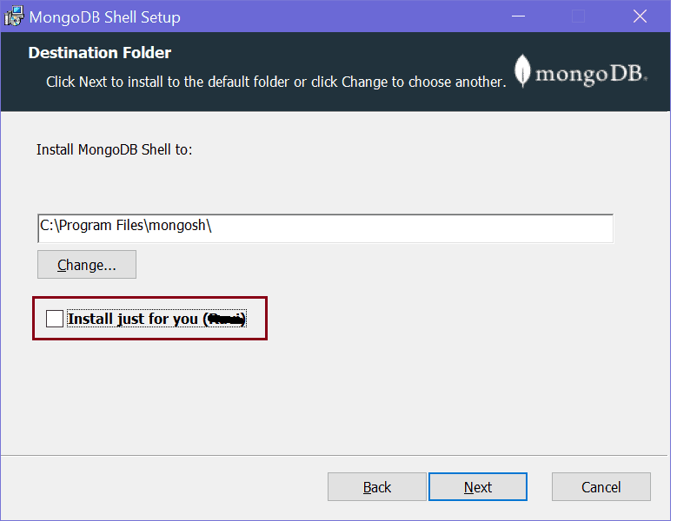Install New MongoDB Shell - mongosh
Here, uncheck the checkbox if you want to install shell for all users on your local machine and click Next.
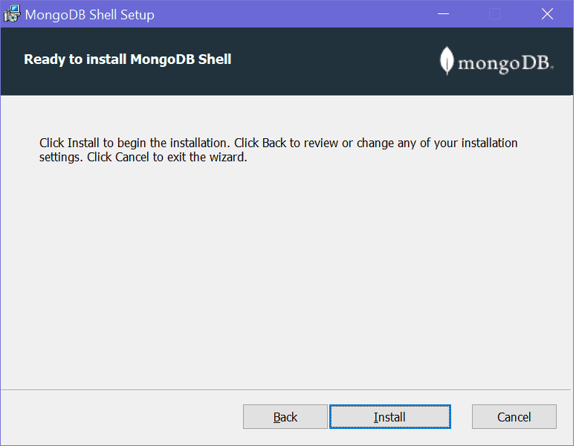Install New MongoDB Shell - mongosh
Click on the Install button to start the installation. It should quickly install it.
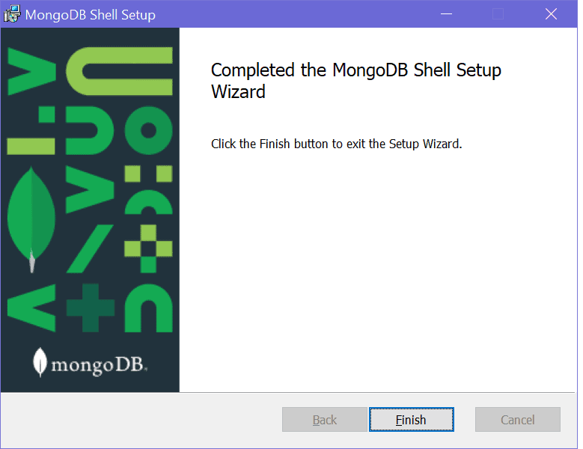Install New MongoDB Shell - mongosh
Once installation completes, click the Finish button to close the wizard.
This should have installed mongosh in "C:\Program Files\mongosh" folder on Windows, as shown below.
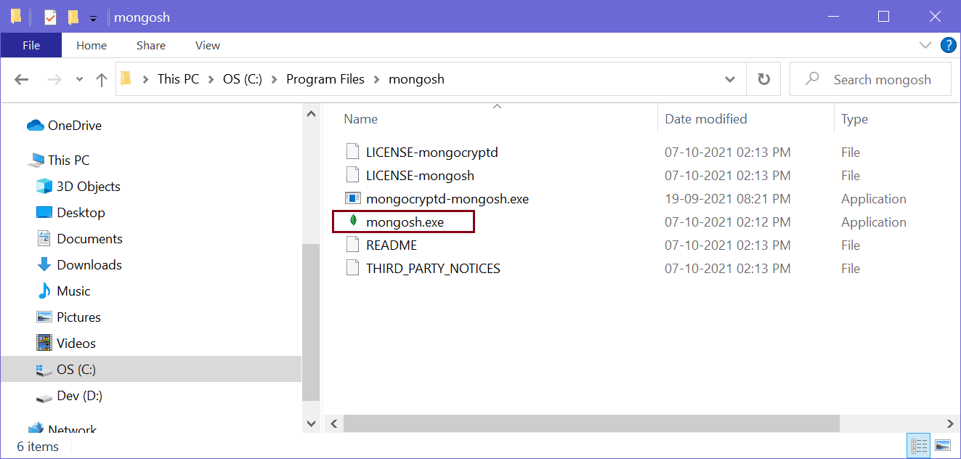New MongoDB Shell - mongosh
Click on the mongosh.exe to open a new MongoDB shell, as shown below.
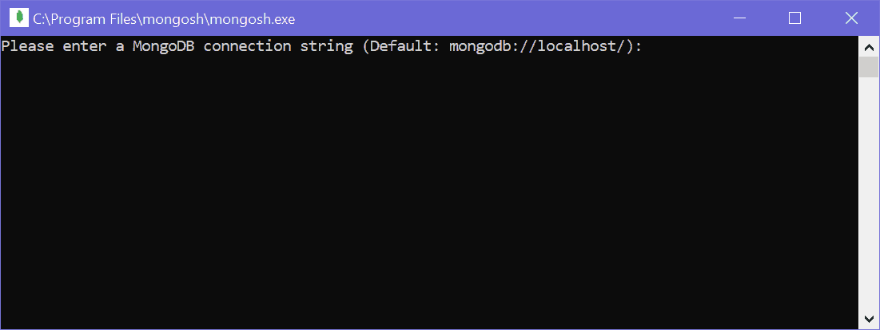New MongoDB Shell - mongosh
Press Enter to start the shell, as shown below.
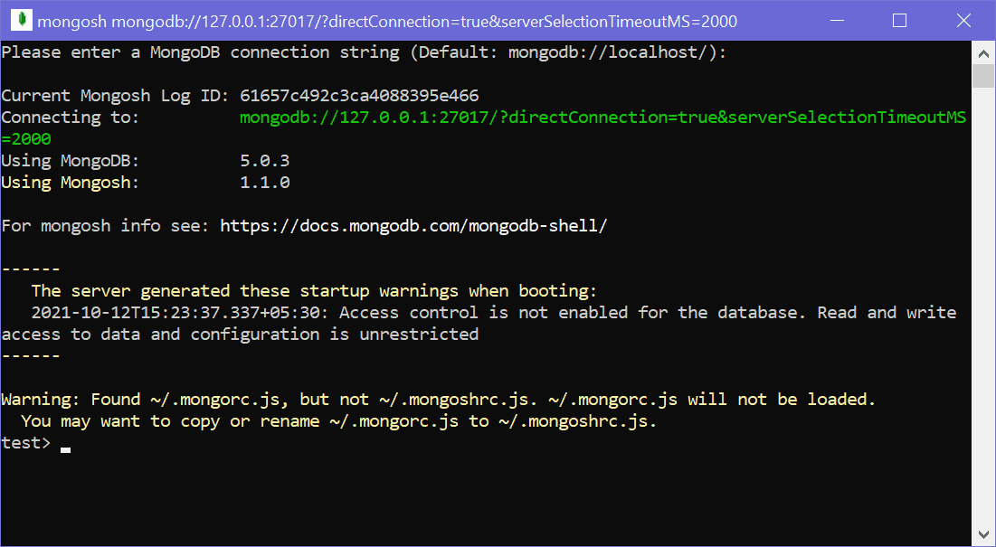New MongoDB Shell - mongosh
Alternatively, open a new command prompt on Windows and write mongosh and press Enter. It will open the same MongoDB shell.

Execute MongoDB Commands
You can execute MongoB commands for CRUD operations on MongoDB shell (mongo or mongosh). For example, execute the "shows dbs" command to see all the databases on the connected MongoDB server.
> show dbs
admin 41 kB
config 111 kB
local 41 kB
Use the "db" command to check the current database.
> db
test
Run the .editor command to execute multi-line commands. Press Ctrl + d to run a command or Ctrl + c to cancel.
MongoDB shell is JavaScript and Node.js REPL, so you can also execute limited JavaScript code.
> "Hello".length
5
Press Ctrl + c twice to exit from the MongoDB shell.

MongoDB Shell Commands
MongoDB Shell is the quickest way to connect, configure, query, and work with your MongoDB database. It acts as a command-line client of the MongoDB server.
You can start MongoDB Shell by executing mongo or mongosh command on the command prompt/terminal. mongosh is the new MongoDB shell with some more features than the old mongo shell.
mongosh <commands>
The --help command display all the commands which you can use with mongo or mongosh, as shown below.
C:\>mongosh --help

$ mongosh [options] [db address] [file names (ending in .js or .mongodb)]

Options:

-h, --help Show this usage information
-f, --file [arg] Load the specified mongosh script
--host [arg] Server to connect to
--port [arg] Port to connect to
--version Show version information
--verbose Increase the verbosity of the output of the shell
--quiet Silence output from the shell during the connection process
--shell Run the shell after executing files
--nodb Don't connect to mongod on startup - no 'db address' [arg] expected
--norc Will not run the '.mongoshrc.js' file on start up
--eval [arg] Evaluate javascript
--retryWrites Automatically retry write operations upon transient network errors

Authentication Options:

-u, --username [arg] Username for authentication
-p, --password [arg] Password for authentication
--authenticationDatabase [arg] User source (defaults to dbname)
--authenticationMechanism [arg] Authentication mechanism
--awsIamSessionToken [arg] AWS IAM Temporary Session Token ID
--gssapiServiceName [arg] Service name to use when authenticating using GSSAPI/Kerberos
--sspiHostnameCanonicalization [arg] Specify the SSPI hostname canonicalization (none or forward, available on Windows)
--sspiRealmOverride [arg] Specify the SSPI server realm (available on Windows)

TLS Options:

--tls Use TLS for all connections
--tlsCertificateKeyFile [arg] PEM certificate/key file for TLS
--tlsCertificateKeyFilePassword [arg] Password for key in PEM file for TLS
--tlsCAFile [arg] Certificate Authority file for TLS
--tlsAllowInvalidHostnames Allow connections to servers with non-matching hostnames
--tlsAllowInvalidCertificates Allow connections to servers with invalid certificates
--tlsCertificateSelector [arg] TLS Certificate in system store (Windows and macOS only)
--tlsCRLFile [arg] Specifies the .pem file that contains the Certificate Revocation List
--tlsDisabledProtocols [arg] Comma separated list of TLS protocols to disable [TLS1_0,TLS1_1,TLS1_2]

API version options:

--apiVersion [arg] Specifies the API version to connect with
--apiStrict Use strict API version mode
--apiDeprecationErrors Fail deprecated commands for the specified API version

FLE Options:

--awsAccessKeyId [arg] AWS Access Key for FLE Amazon KMS
--awsSecretAccessKey [arg] AWS Secret Key for FLE Amazon KMS
--awsSessionToken [arg] Optional AWS Session Token ID
--keyVaultNamespace [arg] database.collection to store encrypted FLE parameters
--kmsURL [arg] Test parameter to override the URL of the KMS endpoint

DB Address Examples:

foo Foo database on local machine
192.168.0.5/foo Foo database on 192.168.0.5 machine
192.168.0.5:9999/foo Foo database on 192.168.0.5 machine on port 9999
mongodb://192.168.0.5:9999/foo Connection string URI can also be used

File Names:

A list of files to run. Files must end in .js and will exit after unless --shell is specified.

Examples:

Start mongosh using 'ships' database on specified connection string:
$ mongosh mongodb://192.168.0.5:9999/ships

For more information on usage: https://docs.mongodb.com/mongodb-shell.
For example, the --nodb allows you to run MongoDB shell without connecting to a database.
C:\>mongosh --nodb
Current Mongosh Log ID: 6166bab1a1acde9f7f388c27
Using Mongosh: 1.1.0

For mongosh info see: https://docs.mongodb.com/mongodb-shell/

Warning: Found ~/.mongorc.js, but not ~/.mongoshrc.js. ~/.mongorc.js will not be loaded.
You may want to copy or rename ~/.mongorc.js to ~/.mongoshrc.js.
>

Connect to MongoDB Database
By default, the mongosh or mongo command connects with the local MongoDB database on the localhost:27017. So, mongosh and mongosh "mongodb://localhost:27017" are the same that connect to a database on the localhost at port 27017.
To connect with the local database on a different port, use the --port option:
C:\>mongosh --port 23023
The following connects to the remote database on mymongodb.example.com at port 23023.
C:\>mongosh "mongodb://mymongodb.example.com:23023"
Or, use the --host and --port options:
mongosh --host mongodb0.example.com --port 28015
Use the --username and --authenticationDatabase command-line options to connect with the database that requires authentication.
mongosh "mongodb://mymongodb.example.com:23023" --username steve --authenticationDatabase admin
Learn more about connect to mongodb options.

MongoDB Command Help
You can also get help on mongosh or mongo commands after connecting to a database using the help command, as shown below.
test> help
Using MongoDB: 5.0.3
Shell Help:: 1.1.0

use Set current database
show 'show databases'/'show dbs': Print a list of all available databases.
'show collections'/'show tables': Print a list of all collections for current database.generated these startup warnings when booting:
'show profile': Prints system.profile information.access to data and conf
'show users': Print a list of all users for current database.
'show roles': Print a list of all roles for current database.
'show log ': log for current connection, if type is not set uses 'global'
'show logs': Print all logs.

exit Quit the MongoDB shell with exit/exit()/.exit
quit Quit the MongoDB shell with quit/quit()
Mongo Create a new connection and return the Mongo object. Usage: new Mongo(URI, options [optional])
connect Create a new connection and return the Database object. Usage: connect(URI, username [optional], password [optional])
it result of the last line evaluated; use to further iterate
version Shell version
load Loads and runs a JavaScript file into the current shell environment
enableTelemetry Enables collection of anonymous usage data to improve the mongosh CLI
disableTelemetry Disables collection of anonymous usage data to improve the mongosh CLI
passwordPrompt Prompts the user for a password
sleep Sleep for the specified number of milliseconds
print Prints the contents of an object to the output
printjson Alias for print()
cls Clears the screen like console.clear()
isInteractive Returns whether the shell will enter or has entered interactive mode

For more information on usage: https://docs.mongodb.com/manual/reference/method
test>

As you can see above, use various commands to work with the connected database. Append .help on the above command to get the help of that command. For example, execute the show.help command to display the help of the show, as shown below.
test> show.help
'show databases'/'show dbs': Print a list of all available databases.
'show collections'/'show tables': Print a list of all collections for current database.
'show profile': Prints system.profile information.
'show users': Print a list of all users for current database.
'show roles': Print a list of all roles for current database.
'show log ': log for current connection, if type is not set uses 'global'
'show logs': Print all logs.

The show dbs command will display all the databases on the connected server.
test> show dbs
admin 41 kB
config 73.7 kB
humanresourcedb 41 kB
local 73.7 kB
The show collections commands shows collections in current database admin.
admin> show collections
system.version
Use the db.help() command to get the help on db command.
test> db.help()
Database Class:

getMongo Returns the current database connection
getName Returns the name of the DB
getCollectionNames Returns an array containing the names of all collections in the current database.
getCollectionInfos Returns an array of documents with collection information, i.e. collection name and options, for the current database.
runCommand Runs an arbitrary command on the database.
adminCommand Runs an arbitrary command against the admin database.
aggregate Runs a specified admin/diagnostic pipeline which does not require an underlying collection.
getSiblingDB Returns another database without modifying the db variable in the shell environment.
getCollection Returns a collection or a view object that is functionally equivalent to using the db..
dropDatabase Removes the current database, deleting the associated data files.
createUser Creates a new user for the database on which the method is run. db.createUser() returns a duplicate user error if the user already exists on the database.
updateUser Updates the user's profile on the database on which you run the method. An update to a field completely replaces the previous field's values. This includes updates to the user's roles array.
changeUserPassword Updates a user's password. Run the method in the database where the user is defined, i.e. the database you created the user.
logout Ends the current authentication session. This function has no effect if the current session is not authenticated.
dropUser Removes the user from the current database.
dropAllUsers Removes all users from the current database.
auth Allows a user to authenticate to the database from within the shell.
grantRolesToUser Grants additional roles to a user.
revokeRolesFromUser Removes a one or more roles from a user on the current database.
getUser Returns user information for a specified user. Run this method on the user's database. The user must exist on the database on which the method runs.
getUsers Returns information for all the users in the database.
createCollection Create new collection
createView Create new view
createRole Creates a new role.
updateRole Updates the role's profile on the database on which you run the method. An update to a field completely replaces the previous field's values.
dropRole Removes the role from the current database.
dropAllRoles Removes all roles from the current database.
grantRolesToRole Grants additional roles to a role.
revokeRolesFromRole Removes a one or more roles from a role on the current database.
grantPrivilegesToRole Grants additional privileges to a role.
revokePrivilegesFromRole Removes a one or more privileges from a role on the current database.
getRole Returns role information for a specified role. Run this method on the role's database. The role must exist on the database on which the method runs.
getRoles Returns information for all the roles in the database.
currentOp Calls the currentOp command. Returns a document that contains information on in-progress operations for the database instance. The db.currentOp() method wraps the database command currentOp.
killOp Calls the killOp command. Terminates an operation as specified by the operation ID. To find operations and their corresponding IDs, see $currentOp or db.currentOp().
shutdownServer Calls the shutdown command. Shuts down the current mongod or mongos process cleanly and safely. You must issue the db.shutdownServer() operation against the admin database.
fsyncLock Calls the fsync command. Forces the mongod to flush all pending write operations to disk and locks the entire mongod instance to prevent additional writes until the user releases the lock with a corresponding db.fsyncUnlock() command.
fsyncUnlock Calls the fsyncUnlock command. Reduces the lock taken by db.fsyncLock() on a mongod instance by 1.
version returns the db version. uses the buildinfo command
serverBits returns the db serverBits. uses the buildInfo command
isMaster Calls the isMaster command
hello Calls the hello command
serverBuildInfo returns the db serverBuildInfo. uses the buildInfo command
serverStatus returns the server stats. uses the serverStatus command
stats returns the db stats. uses the dbStats command
hostInfo Calls the hostInfo command
serverCmdLineOpts returns the db serverCmdLineOpts. uses the getCmdLineOpts command
rotateCertificates Calls the rotateCertificates command
printCollectionStats Prints the collection.stats for each collection in the db.
getFreeMonitoringStatus Calls the getFreeMonitoringStatus command
disableFreeMonitoring returns the db disableFreeMonitoring. uses the setFreeMonitoring command
enableFreeMonitoring returns the db enableFreeMonitoring. uses the setFreeMonitoring command
getProfilingStatus returns the db getProfilingStatus. uses the profile command
setProfilingLevel returns the db setProfilingLevel. uses the profile command
setLogLevel returns the db setLogLevel. uses the setParameter command
getLogComponents returns the db getLogComponents. uses the getParameter command
cloneDatabase deprecated, non-functional
cloneCollection deprecated, non-functional
copyDatabase deprecated, non-functional
commandHelp returns the db commandHelp. uses the passed in command with help: true
listCommands Calls the listCommands command
getLastErrorObj Calls the getLastError command
getLastError Calls the getLastError command
printShardingStatus Calls sh.status(verbose)
printSecondaryReplicationInfo Prints secondary replicaset information
getReplicationInfo Returns replication information
printReplicationInfo Formats sh.getReplicationInfo
printSlaveReplicationInfo DEPRECATED. Use db.printSecondaryReplicationInfo
setSecondaryOk This method is deprecated. Use db.getMongo().setReadPref() instead
watch Opens a change stream cursor on the database
Use db.test.help() command to get the help on collection related commands.
test> db.test.help()

Collection Class:

aggregate Calculates aggregate values for the data in a collection or a view.
bulkWrite Performs multiple write operations with controls for order of execution.
count Returns the count of documents that would match a find() query for the collection or view.
countDocuments Returns the count of documents that match the query for a collection or view.
deleteMany Removes all documents that match the filter from a collection.
deleteOne Removes a single document from a collection.
distinct Finds the distinct values for a specified field across a single collection or view and returns the results in an array.
estimatedDocumentCount Returns the count of all documents in a collection or view.
find Selects documents in a collection or view.
findAndModify Modifies and returns a single document.
findOne Selects documents in a collection or view.
renameCollection Renames a collection.
findOneAndDelete Deletes a single document based on the filter and sort criteria, returning the deleted document.
findOneAndReplace Modifies and replaces a single document based on the filter and sort criteria.
findOneAndUpdate Updates a single document based on the filter and sort criteria.
insert Inserts a document or documents into a collection.
insertMany Inserts multiple documents into a collection.
insertOne Inserts a document into a collection.
isCapped Checks if a collection is capped
remove Removes documents from a collection.
save Updates an existing document or inserts a new document, depending on its document parameter.
replaceOne Replaces a single document within the collection based on the filter.
update Modifies an existing document or documents in a collection.
updateMany Updates all documents that match the specified filter for a collection.
updateOne Updates a single document within the collection based on the filter.
convertToCapped calls {convertToCapped:'coll', size:maxBytes}} command
createIndexes Creates one or more indexes on a collection
createIndex Creates one index on a collection
ensureIndex Creates one index on a collection
getIndexes Returns an array that holds a list of documents that identify and describe the existing indexes on the collection.
getIndexSpecs Alias for getIndexes. Returns an array that holds a list of documents that identify and describe the existing indexes on the collection.
getIndices Alias for getIndexes. Returns an array that holds a list of documents that identify and describe the existing indexes on the collection.
getIndexKeys Return an array of key patterns for indexes defined on collection
dropIndexes Drops the specified index or indexes (except the index on the _id field) from a collection.
dropIndex Drops or removes the specified index from a collection.
totalIndexSize Reports the total size used by the indexes on a collection.
reIndex Rebuilds all existing indexes on a collection.
getDB Get current database.
getMongo Returns the Mongo object.
dataSize This method provides a wrapper around the size output of the collStats (i.e. db.collection.stats()) command.
storageSize The total amount of storage allocated to this collection for document storage.
totalSize The total size in bytes of the data in the collection plus the size of every index on the collection.
drop Removes a collection or view from the database.
exists Returns collection infos if the collection exists or null otherwise.
getFullName Returns the name of the collection prefixed with the database name.
getName Returns the name of the collection.
runCommand Runs a db command with the given name where the first param is the collection name.
explain Returns information on the query plan.
stats Returns statistics about the collection.
latencyStats returns the $latencyStats aggregation for the collection. Takes an options document with an optional boolean 'histograms' field.
initializeOrderedBulkOp Initializes an ordered bulk command. Returns an instance of Bulk
initializeUnorderedBulkOp Initializes an unordered bulk command. Returns an instance of Bulk
getPlanCache Returns an interface to access the query plan cache for a collection. The interface provides methods to view and clear the query plan cache.
mapReduce Calls the mapReduce command
validate Calls the validate command. Default full value is false
getShardVersion Calls the getShardVersion command
getShardDistribution Prints the data distribution statistics for a sharded collection.
watch Opens a change stream cursor on the collection
hideIndex Hides an existing index from the query planner.
unhideIndex Unhides an existing index from the query planner.

MongoDB Compass
MongoDB Compass is a GUI based tools (unline MongoDB Shell) to interact with local or remote MongoDB server and databases. Use Compass to visually explore your data, run ad hoc queries, perform CRUD operations, and view and optimize your query performance. It can be installed on Linux, Mac, or Windows.
If you have not installed MongoDB Compass with the MongoDB, then download the free community version of Compass for your platform from here.
Now, do a window search on "mongodb compass" and open it, as shown below.
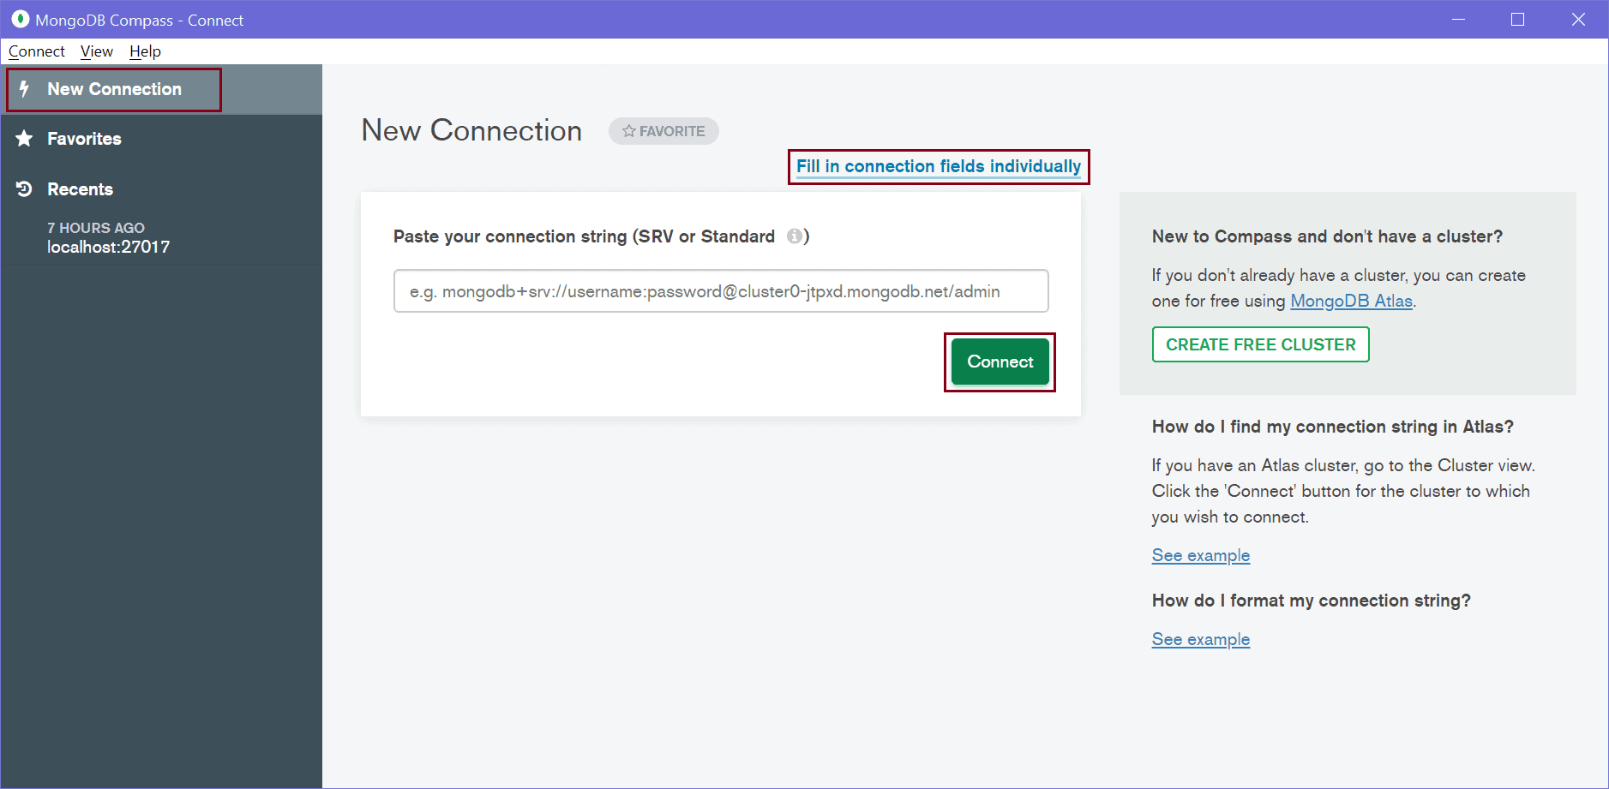MongoDB Compass
On the main page, click on the New Connection tab on the left pane to open New Connection page shown above. You can paste a connection string or click on Fill in connection fields individually link. This will open the following window where you can enter the host name, port, username, password, etc.
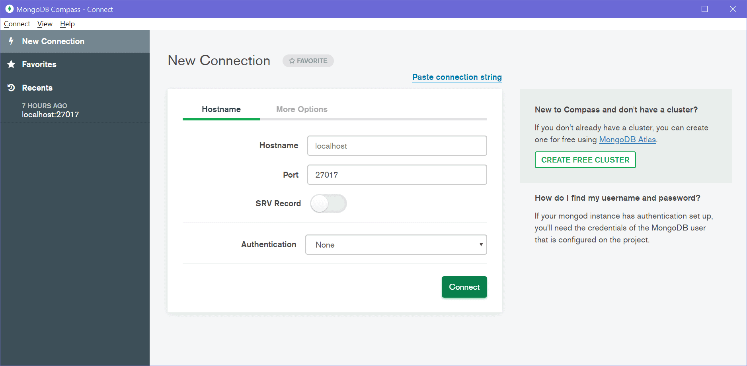MongoDB Compass
This already has default parameters, just click OK to connect with your local server, as shown below.
MongoDB Compass
As you can see above, it will display all the databases on the connected MongoDB server. On the left pane, it displays information about the connected server.
Now, you can create, modify, delete databases, collections, documents using MongoDB Compass. Click on the CREATE DATABASE button to create a new database. This will open Create Database popup, as shown below.
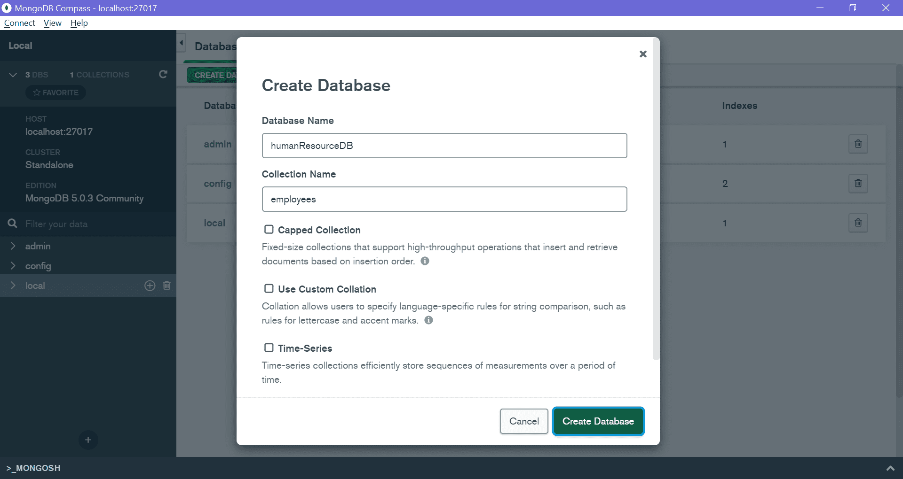MongoDB Compass - Create Database
Enter your database name and collection name and click Create Database. This will create a new database humanResourceDB with the new employees collection shown below.
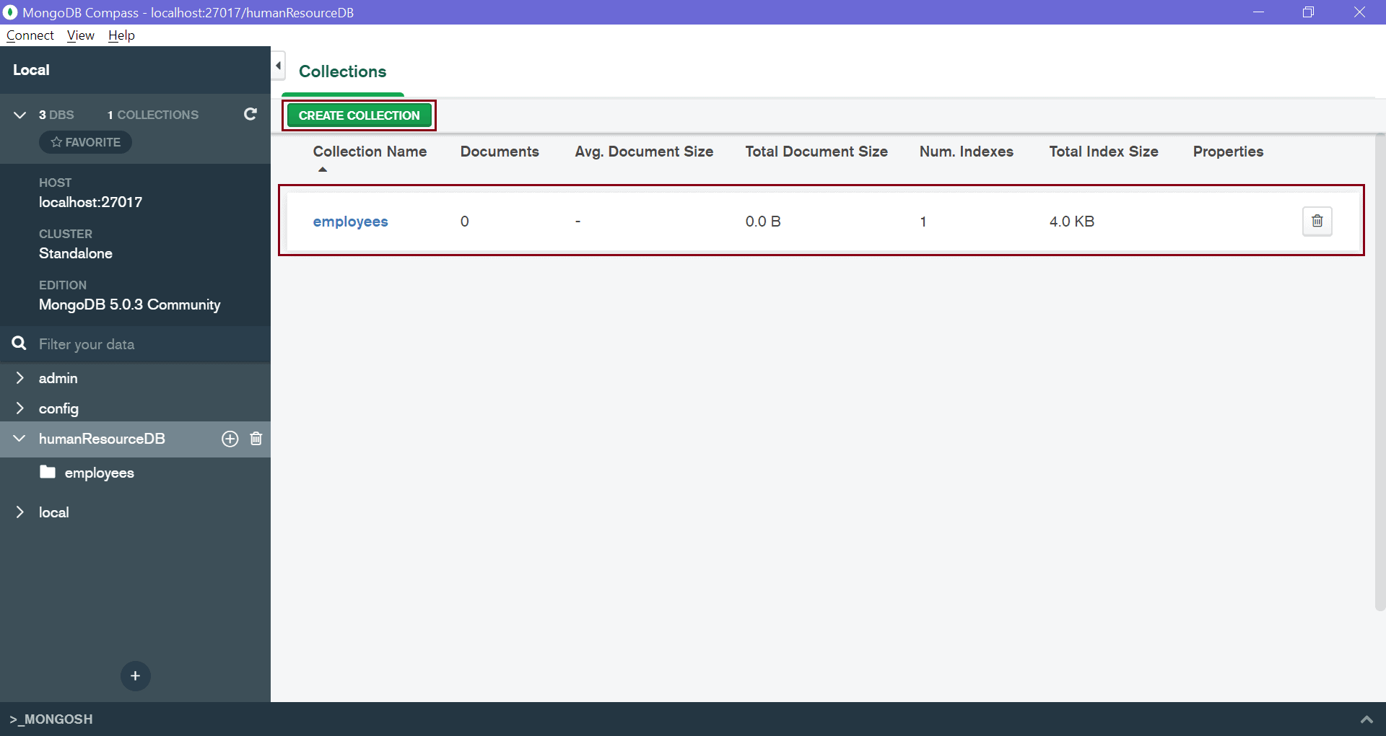MongoDB Compass - Collections
Click on employees collection to insert, update, find documents in it. This will open the following window to manage documents.
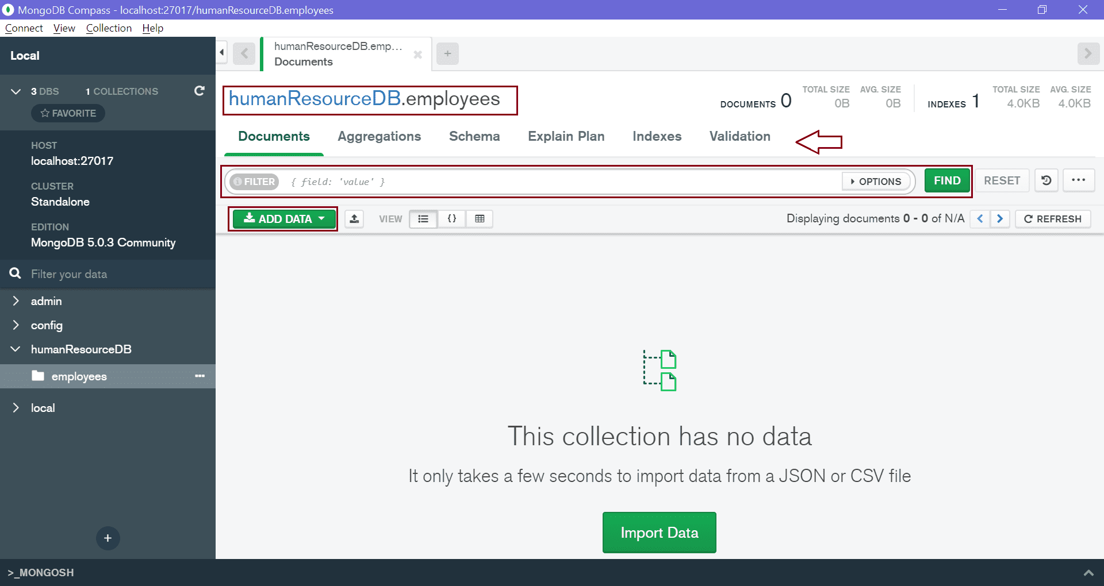MongoDB Compass - Manage Documents
Thus, you can use MongoDB Compass UI to manage your MongoDB databases.

Switch or Create a new MongoDB Database
MongoDB is a document-oriented open-source NoSQL database. It is one of the most popular and widely used NoSQL databases. In this tutorial, you will learn how to create a new MongoDB databases, or switch to an existing one.
A database is a place where data is stored in an organized way. In MongoDB, databases are used to store collections. A single MongoDB server can have multiple databases and a single MongoDB database can have multiple collections.
You can use MongoDB Shell or MongoDB Compass to create a new database.
MongoDB provides the use <database-name command to connect with the database. If the specified database name does not exist then it creates it and set it as a current database.
For example, the following command switch to the "humanResouredb" database. If it does not exist then creates it.
Example: Switch or Create Database
Copy
use humanResourceDB
The following shows how to create or switch MongoDB database in MongoDB shell mongosh:
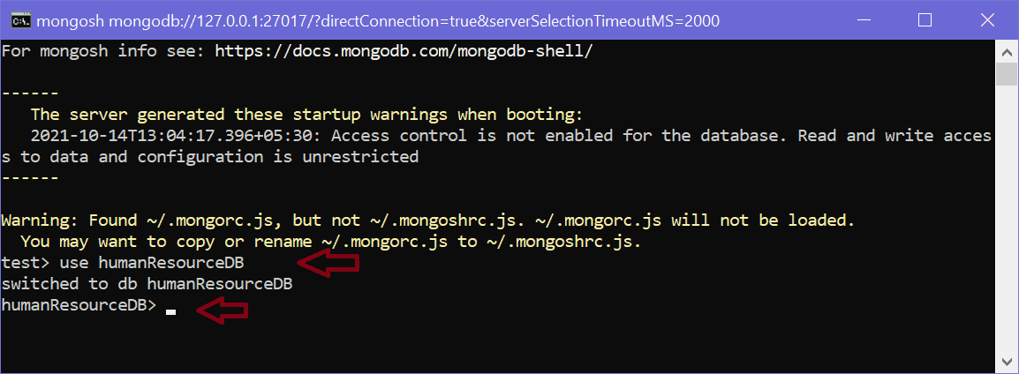Create or Switch Database in MongoDB Shell
MongoDB will automatically switch to the newly created database. Notice that it promts to humanResourceDB> now.
To check all the databases, use the "show dbs" command, as shown below.
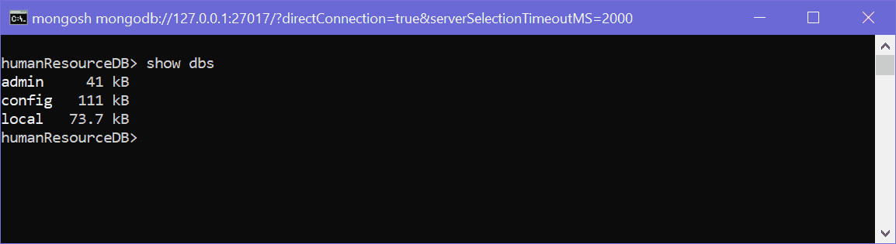List Databases
As you can see above, the "admin", "config", and "local" are default databases. As of now, "humanResourceDB" is not visible. This is because there is no collection in it.
To delete a database, use the db.dropDatabase() method which deletes a current database.
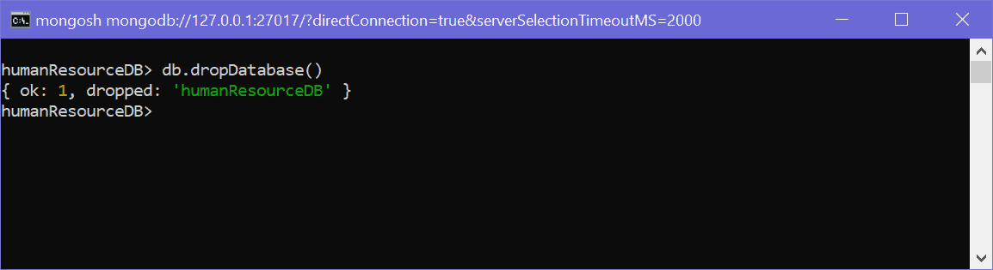Delete Database
Above, { ok: 1, dropped: 'humanResourcedb' } indicates that the database deleted successfully.
Note: Method names are case sensitive. So, executing db.dropdatabase() will throw an error.

Create Database using MongoDB Compass
You can create a new database using MongoDB Compass. For that, open Compass and connect with your local or remote database. Once it connects with the MongoDB server, click on the top "CREATE DATABASE" button which will open the popup window, as shown below.
MongoDB Compass - Create Database
Enter your database name and collection name and click Create Database. This will create a new database humanResourceDB with the new employees collection shown below.
MongoDB Compass - Collections
Thus, you can create a new database in MongoDB.

MongoDB Collections
A collection in MongoDB is similar to a table in RDBMS. MongoDB collections do not enforce schemas. Each MongoDB collection can have multiple documents. A document is equilant to row in a table in RDBMS.
To create a collection, use the db.createCollection() command. The following creates a new employees collection in the current database, which is humanResourceDB database created in the previous chapter.
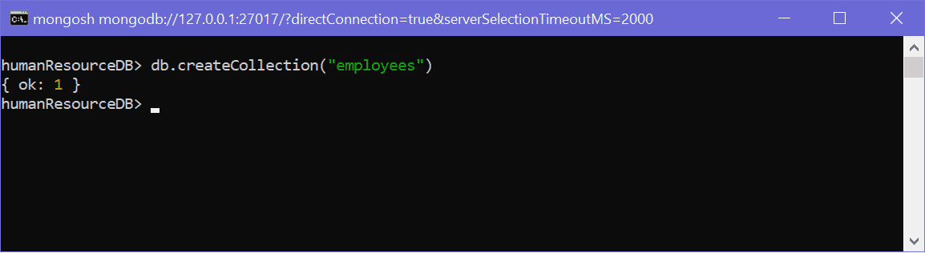Create Collection
Above, the employees collection is created using the createCollection() method. It returns an object { ok: 1 }, which indicates the collection was created successfully.
As mentioned above, a single database can have multiple collections. The following creates multiple collections.
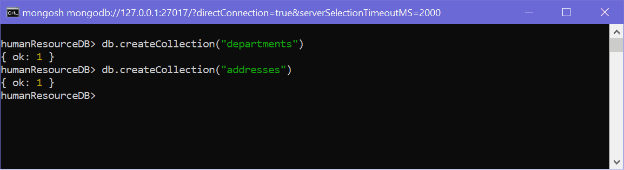Create Multiple Collections
Use the show collections commands to list all the collections in a database.
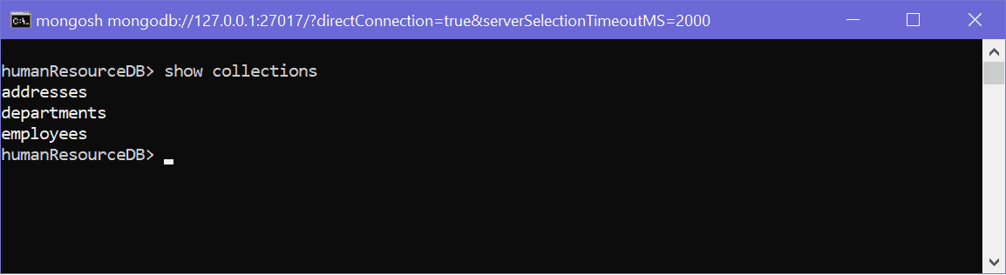Show Collections
To delete a collection, use the db.<collection-name>.drop() method.
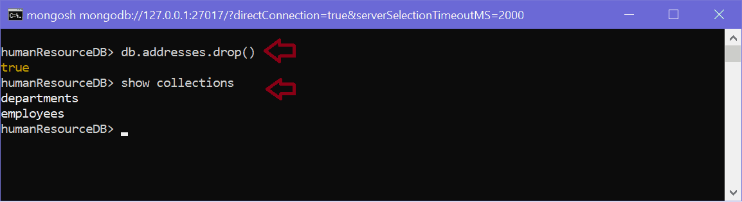Delete Collection

Create Collection in MongoDB Compass
To create a new collection using MongoDB Compass, connect compass to your server and select the database.
Click on the "Create Collection" button to create a new collection, as shown below.

MongoDB Documents: Document, Array, Embedded Document
In the RDBMS database, a table can have multiple rows and columns. Similarly in MongoDB, a collection can have multiple documents which are equivalent to the rows. Each document has multiple "fields" which are equivalent to the columns. So in simple terms, each MongoDB document is a record and a collection is a table that can store multiple documents.
The following is an example of JSON based document.
MongoDB Document
In the above example, a document is contained within the curly braces. It contains multiple fields in "field":"value" format. Above, "_id", "firstName", and "lastName" are field names with their respective values after a colon :. Fields are separated by a comma. A single collection can have multiple such documents separated by a comma.
The following chart to understand the relation between database, collections, and documents.
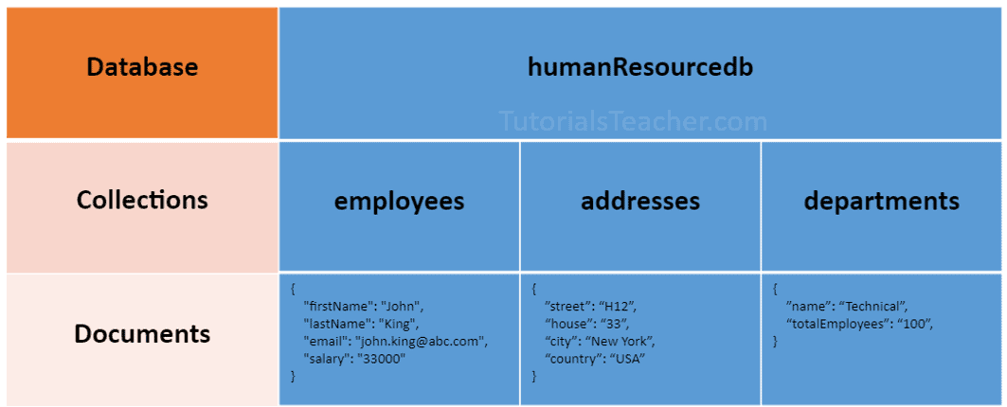MongoDB Database, Collection, and Document
The following is an example of a document that contains an array and an embedded document.
Example: MongoDB Document
Copy
{
"_id": ObjectId("32521df3f4948bd2f54218"),
"firstName": "John",
"lastName": "King",
"email": "john.king@abc.com",
"salary": "33000",
"DoB": new Date('Mar 24, 2011'),
"skills": [ "Angular", "React", "MongoDB" ],
"address": {
"street":"Upper Street",
"house":"No 1",
"city":"New York",
"country":"USA"
}
}
MongoDB document stores data in JSON format. In the above document, "firstName", "lastName", "email", and "salary" are the fields (like columns of a table in RDBMS) with their corresponding values (e.g value of a column in a row). Consider "_id" field as a primary key field that stores a unique ObjectId. "skills" is an array and "address" holds another JSON document.
The field names can be specified without surrounding quotation marks, as shown below.
Example: MongoDB Document
Copy
{
_id: ObjectId("32521df3f4948bd2f54218"),
firstName: "John",
lastName: "King",
email: "john.king@abc.com",
salary: "33000",
DoB: new Date('Mar 24, 2011'),
skills: [ "Angular", "React", "MongoDB" ],
address: {
street:"Upper Street",
house:"No 1",
city:"New York",
country:"USA"
}
}
MongoDB stores data in key-value pairs as a BSON document. BSON is a binary representation of a JSON document that supports more data types than JSON. MongoDB drivers convert JSON document to BSON data.
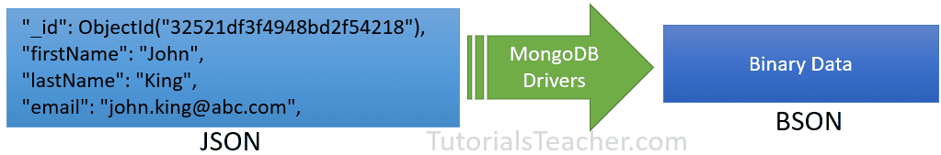JSON vs BSON

Important Points:
- MongoDB reserves _id name for use as a unique primary key field that holds ObjectId type. However, you are free to give any name you like with any data type other than the array.
- A document field name cannot be null but the value can be.
- Most MongoDB documents cannot have duplicate field names. However, it depends on the driver you use to store a document in your application.
- A document fields can be without quotation marks " " if it does not contain spaces, e.g. { name: "Steve"}, { "first name": "Steve"} are valid fields.
- Use the dot notation to access array elements or embedded documents.
- MongoDB supports maximum document size of 16mb. Use GridFS to store more than 16 MB document.
- Fields in a BSON document are ordered. It means fields order is important while comparing two documents, e.g. {x: 1, y: 2} is not equal to {y: 2, x: 1}
- MogoDB keeps the order of the fields except _id field which is always the first field.
- MongoDB collection can store documents with different fields. It does not enforce any schema.

Embedded Documents:
A document in MongoDB can have fields that hold another document. It is also called nested documents.
The following is an embedded document where the department and address field contains another document.
Example: Embedded Document
Copy
{
_id: ObjectId("32521df3f4948bd2f54218"),
firstName: "John",
lastName: "King",
department: {
_id: ObjectId("55214df3f4948bd2f8753"),
name:"Finance"
},
address: {
phone: { type: "Home", number: "111-000-000" }
}
}
In the above embedded document, notice that the address field contains the phone field which holds a second level document.
- An embedded document can contain upto 100 levels of nesting.
- Supports a maximum size of 16 mb.
- Embedded documents can be accessed using dot notation embedded-document.fieldname, e.g. access phone number using address.phone.number.

Array
A field in a document can hold array. Arrays can hold any type of data or embedded documents.
Array elements in a document can be accessed using dot notation with the zero-based index position and enclose in quotes.
Example: MongoDB Document with an Array
Copy
{
_id: ObjectId("32521df3f4948bd2f54218"),
firstName: "John",
lastName: "King",
email: "john.king@abc.com",
skills: [ "Angular", "React", "MongoDB" ],
}
The above document contains the skills field that holds an array of strings. To specify or access the second element in the skills array, use skills.1.

MongoDB - Insert Single Document in a Collection using insertOne()
In MongoDB, a collection represents a table in RDBMS and a document is like a record in a table. Learn how to insert a single document into a collection.
MongoDB provides the following methods to insert documents into a collection:
- insertOne() - Inserts a single document into a collection.
- insert() - Inserts one or more documents into a collection.
- insertMany() - Insert multiple documents into a collection.

insertOne()
Use the db.<collection>.insertOne() method to insert a single document in a collection. db points to the current database, <collection> is existing or a new collection name.

Syntax:
db.collection.insertOne(document, [writeConcern])

Parameters:
- document: A document to insert into the collection.
- writeConcern: Optional. A document expressing the write concern to override the default write concern.
The following inserts a document into employees collection.
Example: insertOne()
Copy
db.employees.insertOne({
firstName: "John",
lastName: "King",
email: "john.king@abc.com"
})
Output
{
acknowledged: true,
insertedId: ObjectId("616d44bea861820797edd9b0")
}
In the above example, we passed a document to the insertOne() method. Notice that we haven't specified _id field. So, MongoDB inserts a document to a collection with the auto-generated unique _id field. It returns an object with a boolean field acknowledged that indicates whether the insert operation is successful or not, and insertedId field with the newly inserted _id value.

MongoDB - Insert Single Document in a Collection using insertOne()
In MongoDB, a collection represents a table in RDBMS and a document is like a record in a table. Learn how to insert a single document into a collection.
MongoDB provides the following methods to insert documents into a collection:
- insertOne() - Inserts a single document into a collection.
- insert() - Inserts one or more documents into a collection.
- insertMany() - Insert multiple documents into a collection.

insertOne()
Use the db.<collection>.insertOne() method to insert a single document in a collection. db points to the current database, <collection> is existing or a new collection name.

Syntax:
db.collection.insertOne(document, [writeConcern])

Parameters:
- document: A document to insert into the collection.
- writeConcern: Optional. A document expressing the write concern to override the default write concern.
The following inserts a document into employees collection.
Example: insertOne()
Copy
db.employees.insertOne({
firstName: "John",
lastName: "King",
email: "john.king@abc.com"
})
Output
{
acknowledged: true,
insertedId: ObjectId("616d44bea861820797edd9b0")
}
In the above example, we passed a document to the insertOne() method. Notice that we haven't specified _id field. So, MongoDB inserts a document to a collection with the auto-generated unique _id field. It returns an object with a boolean field acknowledged that indicates whether the insert operation is successful or not, and insertedId field with the newly inserted _id value.

MongoDB - Insert Single Document in a Collection using insertOne()
In MongoDB, a collection represents a table in RDBMS and a document is like a record in a table. Learn how to insert a single document into a collection.
MongoDB provides the following methods to insert documents into a collection:
- insertOne() - Inserts a single document into a collection.
- insert() - Inserts one or more documents into a collection.
- insertMany() - Insert multiple documents into a collection.

insertOne()
Use the db.<collection>.insertOne() method to insert a single document in a collection. db points to the current database, <collection> is existing or a new collection name.

Syntax:
db.collection.insertOne(document, [writeConcern])

Parameters:
- document: A document to insert into the collection.
- writeConcern: Optional. A document expressing the write concern to override the default write concern.
The following inserts a document into employees collection.
Example: insertOne()
Copy
db.employees.insertOne({
firstName: "John",
lastName: "King",
email: "john.king@abc.com"
})
Output
{
acknowledged: true,
insertedId: ObjectId("616d44bea861820797edd9b0")
}
In the above example, we passed a document to the insertOne() method. Notice that we haven't specified _id field. So, MongoDB inserts a document to a collection with the auto-generated unique _id field. It returns an object with a boolean field acknowledged that indicates whether the insert operation is successful or not, and insertedId field with the newly inserted _id value.
The following shows the insert operation in the mongosh shell:
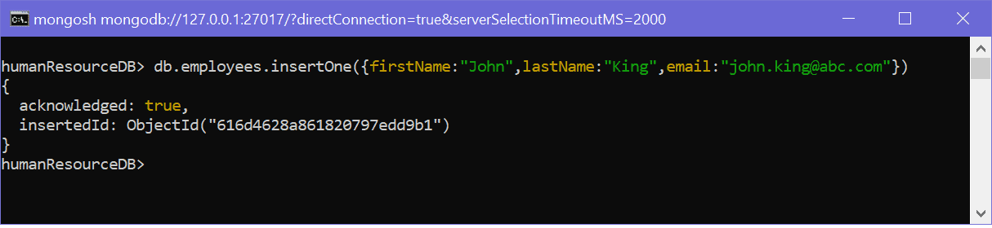InsertOne() in mongosh Shell
Use the find() to list all data of a collection, and the pretty() method to format resulted data.
db.employees.find().pretty()
Output
{
_id: ObjectId("616d44bea861820797edd9b0"),
firstName: "John",
lastName: "King",
email: "john.king@abc.com"
}
MongoDB is NoSQL database. So, it does not enforce schema to any collection. It means you can insert a document with any fields to a collection. For example, the following inserts a document with different fields to the employees collection.
Example: Insert a Document
Copy
db.employees.insertOne({
fName: "John",
lName: "King",
emailid: "john.king@abc.com"
})
Output
{
acknowledged: true,
insertedId: ObjectId("546d44bea861820797ed214")
}
It is recommended to keep the field names same in all the documents of a collection to manage them easily.

Insert _id Manually
It is not necessary to insert auto-generated _id value. You can manually specify a unique value for the _id field, as shown below.
Example: Insert a Document
Copy
db.employees.insertOne({
_id:"1",
firstName: "John",
lastName: "King",
email: "john.king@abc.com"
})
Output
{
acknowledged: true,
insertedId: 1
}
Note that while adding your custom value to _id field, a value must be unique; otherwise, it will throw an error. The following tries to add the same _id value.
Example: Insert a Document
Copy
db.employees.insertOne({
_id:"1",
firstName: "John",
lastName: "King",
email: "john.king@abc.com"
})
Output
MongoServerError: E11000 duplicate key error collection: humanResourceDB.employee

MongoDB - Insert Multiple Documents in a Collection
In MongoDB, a collection represents a table in RDBMS and a document is like a record in a table. Learn how to insert one or more documents into a collection.
MongoDB provides the following methods to insert documents into a collection:
- insertOne() - Inserts a single document into a collection.
- insert() - Inserts one or more documents into a collection.
- insertMany() - Insert multiple documents into a collection.

insert()
The db.<collection>.insert() method inserts one document or an array of documents into a collection.

Syntax:
db.collection.insert(
document or array of documents,
[writeConcern],
[ordered])

Parameters:
- document or array of documents: A single document or array of documents to insert into the collection.
- writeConcern: Optional. A document expressing the write concern to override the default write concern.
- ordered: Optional. A boolean value indicating whether it's ordered or unordered insert operation. If true then performs ordered insert where if an error occurs with one of the documents, then MongoDB will return without processing the remaining documents in the array. If false, then process all the documents even if an error occurred. Defaults to true.
The following inserts a single document. It's the same as the insertOne() method.
Example: insert()
Copy
db.employees.insert({
firstName: "John",
lastName: "King",
email: "john.king@abc.com"
})
Output
{
acknowledged: true,
insertedIds: { '0': ObjectId("616d62d9a861820797edd9b2") }
}
The following inserts multiple documents into a collection by passing an array of documents.
Example: Insert a Document
Copy
db.employees.insert(
[
{
firstName: "John",
lastName: "King",
email: "john.king@abc.com"
},
{
firstName: "Sachin",
lastName: "T",
email: "sachin.t@abc.com"
},
{
firstName: "James",
lastName: "Bond",
email: "jamesb@abc.com"
}
])
Output
{
acknowledged: true,
insertedIds: {
'0': ObjectId("616d63eda861820797edd9b3"),
'1': ObjectId("616d63eda861820797edd9b4"),
'2': ObjectId("616d63eda861820797edd9b5")
}
}
You can specify a different _id field value into one or more documents, as shown below.
Example: Insert a Document
Copy
db.employees.insert(
[
{
firstName: "John",
lastName: "King",
email: "john.king@abc.com"
},
{
_id:1,
firstName: "Sachin",
lastName: "T",
email: "sachin.t@abc.com"
},
{
firstName: "James",
lastName: "Bond",
email: "jamesb@abc.com"
},
])
Output
{
acknowledged: true,
insertedIds: {
'0': ObjectId("616d63eda861820797edd9b3"),
'1': 1,
'2': ObjectId("616d63eda861820797edd9b5")
}
}
By default, the insert() method performs ordered inserts. So, if an error occurred in any of the documents, then it won't process the remaining documents. For example, the following tries to insert a second document with an existing _id value.
Example: Insert a Document
Copy
db.employees.insert(
[
{
firstName: "Steve",
lastName: "J",
email: "steve.j@abc.com"
},
{
_id:1,
firstName: "Kapil",
lastName: "D",
email: "kapil.d@abc.com"
},
{
firstName: "Amitabh",
lastName: "B",
email: "amitabh.b@abc.com"
},
])
Output
Uncaught:
MongoBulkWriteError: E11000 duplicate key error collection: humanResourceDB.employees index: _id_ dup key: { _id: 1 }
Result: BulkWriteResult {
result: {
ok: 1,
writeErrors: [
WriteError {
err: {
index: 1,
code: 11000,
errmsg: 'E11000 duplicate key error collection: humanResourceDB.employees index: _id_ dup key: { _id: 1 }',
errInfo: undefined,
op: {
_id: 1,
firstName: 'Kapil',
lastName: 'D',
email: 'kapil.d@abc.com'
}
}
}
],
writeConcernErrors: [],
insertedIds: [
{ index: 0, _id: ObjectId("616e6b7e3fa8bd4420d49371") },
{ index: 1, _id: 1 },
{ index: 2, _id: ObjectId("616e6b7e3fa8bd4420d49372") }
],
nInserted: 1,
nUpserted: 0,
nMatched: 0,
nModified: 0,
nRemoved: 0,
upserted: []
}
}
In the above output, it encounters an error while inserting the second document. So, it only inserts the first document. nInserted indicates the number of documents inserted successfully.
Specify the {ordered:false} to perform unorder insert which will insert all the valid documents even if an error occurs.
Example: Insert a Document
Copy
db.employees.insert(
[
{
firstName: "Steve",
lastName: "J",
email: "steve.j@abc.com"
},
{
_id:1,
firstName: "Kapil",
lastName: "D",
email: "kapil.d@abc.com"
},
{
firstName: "Amitabh",
lastName: "B",
email: "amitabh.b@abc.com"
},
],
{ ordered: false}
)
Output
Uncaught:
MongoBulkWriteError: E11000 duplicate key error collection: humanResourceDB.employees index: _id_ dup key: { _id: 1 }
Result: BulkWriteResult {
result: {
ok: 1,
writeErrors: [
WriteError {
err: {
index: 1,
code: 11000,
errmsg: 'E11000 duplicate key error collection: humanResourceDB.employees index: _id_ dup key: { _id: 1 }',
errInfo: undefined,
op: {
_id: 1,
firstName: 'Kapil',
lastName: 'D',
email: 'kapil.d@abc.com'
}
}
}
],
writeConcernErrors: [],
insertedIds: [
{ index: 0, _id: ObjectId("616e6be33fa8bd4420d49373") },
{ index: 1, _id: 1 },
{ index: 2, _id: ObjectId("616e6be33fa8bd4420d49374") }
],
nInserted: 2,
nUpserted: 0,
nMatched: 0,
nModified: 0,
nRemoved: 0,
upserted: []
}
}

insertMany()
The db.<collection>.insertMany() inserts multiple documents into a collection. It cannot insert a single document.

Syntax:
db.collection.insertMany(
[document1, document2, ....],
{
writeConcern: <document>,
ordered: <boolean>
}
)
The following adds multiple documents using the insertMany() method.
Example: Insert a Document
Copy
db.employees.insertMany(
[
{
firstName: "John",
lastName: "King",
email: "john.king@abc.com"
},
{
firstName: "Sachin",
lastName: "T",
email: "sachin.t@abc.com"
},
{
firstName: "James",
lastName: "Bond",
email: "jamesb@abc.com"
},
])
Output
{
acknowledged: true,
insertedIds: {
'0': ObjectId("616d63eda861820797edd9b3"),
'1': ObjectId("616d63eda861820797edd9b4"),
'2': ObjectId("616d63eda861820797edd9b5")
}
}
The following inserts custom _id values.
Example: insertMany() with Custom _id
Copy
db.employees.insertMany([
{
_id:1,
firstName: "John",
lastName: "King",
email: "john.king@abc.com",
salary: 5000
},
{
_id:2,
firstName: "Sachin",
lastName: "T",
email: "sachin.t@abc.com",
salary: 8000
},
{
_id:3,
firstName: "James",
lastName: "Bond",
email: "jamesb@abc.com",
salary: 7500
},
{
_id:4,
firstName: "Steve",
lastName: "J",
email: "steve.j@abc.com",
salary: 9000

},
{
_id:5,
firstName: "Kapil",
lastName: "D",
email: "kapil.d@abc.com",
salary: 4500

},
{
_id:6,
firstName: "Amitabh",
lastName: "B",
email: "amitabh.b@abc.com",
salary: 11000
}
])
Output
{
acknowledged: true,
insertedIds: { '0': 1, '1': 2, '2': 3, '3': 4, '4': 5, '5': 6 }
}
Use the ordered parameter the same way as the insert() method to process all the documents even if an error occurred.
Note: If the collection used with these methods does not exist, then they create the specified collection. MongoDB is case-sensitive, so employees and Employees are considered two different collections.

MongoDB: Find Single Document from Collection using findOne()
In MongoDB, a collection represents a table in RDBMS and a document is like a record in a table. Here you will learn how to retrieve or find a single document from a collection.
MongoDB provides two methods for finding documents from a collection:
- findOne() - returns a the first document that matched with the specified criteria.
- find() - returns a cursor to the selected documents that matched with the specified criteria.
The following inserts documents in the employees collection.
Sample Data
Copy
db.employees.insertMany([
{
_id:1,
firstName: "John",
lastName: "King",
email: "john.king@abc.com",
salary: 5000
},
{
_id:2,
firstName: "Sachin",
lastName: "T",
email: "sachin.t@abc.com",
salary: 8000
},
{
_id:3,
firstName: "James",
lastName: "Bond",
email: "jamesb@abc.com",
salary: 7500
},
{
_id:4,
firstName: "Steve",
lastName: "J",
email: "steve.j@abc.com",
salary: 9000

},
{
_id:5,
firstName: "Kapil",
lastName: "D",
email: "kapil.d@abc.com",
salary: 4500

},
{
_id:6,
firstName: "Amitabh",
lastName: "B",
email: "amitabh.b@abc.com",
salary: 11000
}
])

findOne()
The findOne() method returns the first document that is matched with the specified criteria.

Syntax:
db.collection.findOne(query, projection)

Parameters:
- query: Optional. Specifies the criteria using query operators.
- projection: Optional. Specifies the fields to include in a resulted document.
The findOne() returns the first document from a collection if no parameter is passed.
Example: find()
Copy
db.employees.findOne()
Output
{
_id: 1,
firstName: 'John',
lastName: 'King',
email: 'john.king@abc.com',
salary: 5000
}
Specify a criteria as { field: "value", field:"value",..} on which you want to find a document. For example, the following returns a document where firstName field is "Kapil".
Example: find()
Copy
db.employees.findOne({firstName: "Kapil"})
Output
{
_id: 5,
firstName: 'Kapil',
lastName: 'D',
email: 'kapil.d@abc.com',
salary: 4500
}
The findOne() method performs the case-sensitive search, so {firstName: "Kapil"} and {firstName: "kapil"} returns different result.
It returns null if it cannot find a document matching the specified criteria.
Example: find()
Copy
db.employees.findOne({_id:10})
Output
null
Use the query operators for more refined search. For example, the following finds the first document where salary is greater than 8000.
Example: find()
Copy
db.employees.findOne({salary: {$gt: 8000}})
Output
{
_id: 4,
firstName: 'Steve',
lastName: 'J',
email: 'steve.j@abc.com',
salary: 9000
}
In the above example, the query operator criteria for the salary field is written inside another document as {field: {operator: value}}. The {salary: {$gt: 8000}} criteria returns the first document where salary is greater than 8000.

Projection
Use the projection parameter to specify the fields to be included in the result. The projection parameter format is {<field>: <1 or true>, <field>: <1 or true>...} where 1 or true includes the field, and o or false excludes the field in the result.
Example: find()
Copy
db.employees.findOne({firstName: "Sachin"}, {firstName:1, lastName:1})
Output
{ _id: 2, firstName: 'Sachin', lastName: 'T' }
Note that by default, the _id field will be included in the result. To omit it, specify { _id:0 } in the projection.
Example: find()
Copy
db.employees.findOne({firstName: "Sachin"}, {_id: 0, firstName:1, lastName:1})
Output
{ firstName: 'Sachin', lastName: 'T' }

Find Documents using the find() Method
The find() method finds all the documents that matches with the specified criteria and returns the cursor object. The cursor object is a pointer to the result set.

Syntax:
db.collection.find(query, projection)

Parameters:
- query: Optional. Specifies the criteria using query operators.
- projection: Optional. Specifies the fields to include in a resulted document.
The find() returns all the documents from a collection if no parameter is passed. The following executes the db.employees.find() in mongosh shell:
humanResourceDB> db.employees.find()
[
{
_id:1,
firstName: "John",
lastName: "King",
email: "john.king@abc.com",
salary: 5000,
skills: [ "Angular", "React", "MongoDB" ],
department: { "name":"IT" }
},
{
_id:2,
firstName: "Sachin",
lastName: "T",
email: "sachin.t@abc.com",
salary: 8000,
skills: [ "Accounting", "Tax" ],
department: { "name":"Finance" }
},
{
_id:3,
firstName: "James",
lastName: "Bond",
email: "jamesb@abc.com",
salary: 7500,
skills: [ "Sales", "Marketing" ],
department: { "name":"Marketing" }
},
{
_id:4,
firstName: "Steve",
lastName: "J",
email: "steve.j@abc.com",
salary: 7000

},
{
_id:5,
firstName: "Kapil",
lastName: "D",
email: "kapil.d@abc.com",
salary: 4500,
skills: [ "Accounting", "Tax" ],
department: { "name":"Finance" }

},
{
_id:6,
firstName: "Amitabh",
lastName: "B",
email: "amitabh.b@abc.com",
salary: 7000
}
]
Executing db.collection.find() in mongosh shell automatically iterates the cursor to display up to the first 20 documents. Type it to continue iteration.
You can specify the criteria as { field: "value", field:"value",..} on which you want to find a document. For example, the following returns all the documents where salary is 7000.
Example: find(criteria)
Copy
db.employees.find({salary: 7000})
Output
[{
_id:4,
firstName: "Steve",
lastName: "J",
email: "steve.j@abc.com",
salary: 7000

},
{
_id:6,
firstName: "Amitabh",
lastName: "B",
email: "amitabh.b@abc.com",
salary: 7000
}
]
The find() method performs the case-sensitive search, so {firstName: "Kapil"} and {firstName: "kapil"} returns different result.
Use the query operators for more refined search. For example, the following finds the first document where salary is greater than 8000.
Example: find() with Query Operator
Copy
db.employees.find({salary: {$gt: 7000}})
Output
[{
_id: 2,
firstName: 'Sachin',
lastName: 'T',
email: 'sachin.t@abc.com',
salary: 8000,
skills: [ 'Accounting', 'Tax' ],
department: { name: 'Finance' }
},
{
_id: 3,
firstName: 'James',
lastName: 'Bond',
email: 'jamesb@abc.com',
salary: 7500,
skills: [ 'Sales', 'Marketing' ],
department: { name: 'Marketing' }
}]
Specify multiple criteria by adding another query operator as field. The following retrieves documents whose salary field is greater than 7000 and less than 8000.
Example: find() with Multiple Query Operator
Copy
db.employees.find({salary: {$gt: 7000, $lt: 8000}})
Output
[{
_id: 3,
firstName: 'James',
lastName: 'Bond',
email: 'jamesb@abc.com',
salary: 7500,
skills: [ 'Sales', 'Marketing' ],
department: { name: 'Marketing' }
}]

Query Embedded Document
You can specify criteria for embedded document fields using dot notation, as shown below.
Example: find() with Multiple Query Operator
Copy
db.employees.find({ "department.name": "Finance"})
Output
[
{
_id: 2,
firstName: 'Sachin',
lastName: 'T',
email: 'sachin.t@abc.com',
salary: 8000,
skills: [ 'Accounting', 'Tax' ],
department: { name: 'Finance' }
},
{
_id: 5,
firstName: 'Kapil',
lastName: 'D',
email: 'kapil.d@abc.com',
salary: 4500,
skills: [ 'Accounting', 'Tax' ],
department: { name: 'Finance' }
}
]

Query Array Elements
You can find documents based on the array element, index, or size.
Example: find() on Array
Copy
db.employees.find({ "skills": "Tax"}) //returns documents where skills contains "Tax"
db.employees.find({ "skills": { $in: [ "Tax", "Sales" ]}}) //returns documents where skills contains "Tax" or "Sales"
db.employees.find({ "skills": { $all: [ "Tax", "Accounting" ]}}) //returns documents where skills contains "Tax" and "Accounting"
db.employees.find({ "skills": { $size: 3}) //returns documents where skills contains 3 elements

Projection
Use the projection parameter to specify the fields to be included in the result. The projection parameter format is {<field>: <1 or true>, <field>: <1 or true>...} where 1 or true includes the field, and o or false excludes the field in the result.
Example: find()
Copy
db.employees.find({salary: 7000}, {firstName:1, lastName:1})
Output
[{
_id:4,
firstName: "Steve",
lastName: "J",
},
{
_id:6,
firstName: "Amitabh",
lastName: "B",
}]
Note that by default, the _id field will be included in the result. To omit it, specify { _id:0 } in the projection.
Example: find()
Copy
db.employees.findOne({firstName: "Sachin"}, {_id: 0, firstName:1, lastName:1})
Output
[{
firstName: "Steve",
lastName: "J",
},
{
firstName: "Amitabh",
lastName: "B",
}]

MongoDB Cursor
The find() method returns a cursor object which can be used to iterate the result.
The following example gets the cursor object and assign it to a variable.
Example: Cursor Object
Copy
var cursor = db.employees.find()
The cursor object has the following important methods:
The following example shows how to use next() method in mongosh shell.
humanResourceDB> var cur = db.employees.find()

humanResourceDB> cur.next()
{
_id:1,
firstName: "John",
lastName: "King",
email: "john.king@abc.com",
salary: 5000
}
humanResourceDB> cur.next()
{
_id:2,
firstName: "Sachin",
lastName: "T",
email: "sachin.t@abc.com",
salary: 8000
}
humanResourceDB> cur.next()
{
_id:3,
firstName: "James",
lastName: "Bond",
email: "jamesb@abc.com",
salary: 7500
}
humanResourceDB> cur.next()
{
_id:4,
firstName: "Steve",
lastName: "J",
email: "steve.j@abc.com",
salary: 7000

}
humanResourceDB> cur.next()
{
_id:5,
firstName: "Kapil",
lastName: "D",
email: "kapil.d@abc.com",
salary: 4500

}
humanResourceDB> cur.next()
{
_id:6,
firstName: "Amitabh",
lastName: "B",
email: "amitabh.b@abc.com",
salary: 7000
}
humanResourceDB> cur.next()
null
humanResourceDB> cur.next()
MongoCursorExhaustedError: Cursor is exhausted
In the above example, if the cursor reaches at the end, it will MongoCursorExhaustedError: Cursor is exhausted. Use the hasNext() method before calling the next() to prevent an error.
Use cursor.forEach() method to iterate the result. Specify the built-in printjson method to print the result, as shown below.
humanResourceDB> var cur = db.employees.find()

humanResourceDB> cur.forEach(printjson)
{
_id:1,
firstName: "John",
lastName: "King",
email: "john.king@abc.com",
salary: 5000
}
{
_id:2,
firstName: "Sachin",
lastName: "T",
email: "sachin.t@abc.com",
salary: 8000
}
{
_id:3,
firstName: "James",
lastName: "Bond",
email: "jamesb@abc.com",
salary: 7500
}
{
_id:4,
firstName: "Steve",
lastName: "J",
email: "steve.j@abc.com",
salary: 7000

}
{
_id:5,
firstName: "Kapil",
lastName: "D",
email: "kapil.d@abc.com",
salary: 4500

}
{
_id:6,
firstName: "Amitabh",
lastName: "B",
email: "amitabh.b@abc.com",
salary: 7000
}
Learn how to sort documents using cursor.sort() method in the next chapter.

Sort Documents in MongoDB Collection
MongoDB provides the db.collection.find() method returns a cursor object for the resulted documents. Use the cursor.sort() method or db.collection.find().sort() to sort the resulted documents in a cursor based on the specified order.

Syntax:
db.collection.find().sort(document)

Parameters:
- document: A document that defines the sort order in {field: 1, field:-1,...} format where 1 is for ascending order and -1 is for descending order.
The following inserts documents in the employees collection.
Sample Data
Copy
db.employees.insertMany([
{
_id:1,
firstName: "John",
lastName: "King",
email: "john.king@abc.com",
salary: 5000,
skills: [ "Angular", "React", "MongoDB" ],
department: {
"name":"IT"
}
},
{
_id:2,
firstName: "Sachin",
lastName: "T",
email: "sachin.t@abc.com",
salary: 8000,
skills: [ "Accounting", "Tax" ],
department: {
"name":"Finance"
}
},
{
_id:3,
firstName: "James",
lastName: "Bond",
email: "jamesb@abc.com",
salary: 7500,
skills: [ "Sales", "Marketing" ],
department: {
"name":"Marketing"
}
},
{
_id:4,
firstName: "Steve",
lastName: "J",
email: "steve.j@abc.com",
salary: 7000

},
{
_id:5,
firstName: "Kapil",
lastName: "D",
email: "kapil.d@abc.com",
salary: 4500,
skills: [ "Accounting", "Tax" ],
department: {
"name":"Finance"
}

},
{
_id:6,
firstName: "Amitabh",
lastName: "B",
email: "amitabh.b@abc.com",
salary: 7000
}
])
The following example sorts the employees collection in the ascending order of the firstName field.
Example: sort()
Copy
db.employees.find().sort({ firstName:1 })
Output
[
{
_id: 6,
firstName: 'Amitabh',
lastName: 'B',
email: 'amitabh.b@abc.com',
salary: 7000
},
{
_id: 3,
firstName: 'James',
lastName: 'Bond',
email: 'jamesb@abc.com',
salary: 7500,
skills: [ 'Sales', 'Marketing' ],
department: { name: 'Marketing' }
},
{
_id: 1,
firstName: 'John',
lastName: 'King',
email: 'john.king@abc.com',
salary: 5000,
skills: [ 'Angular', 'React', 'MongoDB' ],
department: { name: 'IT' }
},
{
_id: 5,
firstName: 'Kapil',
lastName: 'D',
email: 'kapil.d@abc.com',
salary: 4500,
skills: [ 'Accounting', 'Tax' ],
department: { name: 'Finance' }
},
{
_id: 2,
firstName: 'Sachin',
lastName: 'T',
email: 'sachin.t@abc.com',
salary: 8000,
skills: [ 'Accounting', 'Tax' ],
department: { name: 'Finance' }
},
{
_id: 4,
firstName: 'Steve',
lastName: 'J',
email: 'steve.j@abc.com',
salary: 7000
}
]
You can use the cursor object to sort the result. The following returns the same result as above.
Example: cursor.sort()
Copy
var cursor = db.employees.find()
cursor.sort({ firstName:1 })
The following example list the sorting on different fields.
Example: sort()
Copy
db.employees.find().sort({ _id: -1 })// sorts by descending order of _id
db.employees.find().sort({ salary: -1 })// sorts by descending order of salary
db.employees.find({salary: {$gt:5000}}).sort({ salary: -1 })// find where salary > 5000 and sorts the result by descending order of salary
db.employees.find().sort({ firstName:1, salary: -1 })// sorts by ascending order of firstName and descending order of salary
db.employees.find().sort({"department.name":1}) // sorts by embedded doc department.name

Update Single Document using updateOne() in MongoDB
Learn how to update a single document using the updateOne() method in MongoDB.
MongoDB provides the following methods to update existing documents in a collection:
- db.collection.updateOne() - Modifies a single document in a collection.
- db.collection.updateMany() - Modifies one or more documents in a collection.

db.collection.updateOne()
Use the db.<collection>.updateOne() method to update a single document in a collection that matches with the specified filter criteria. It updates the first matching document even if multiple documents match with the criteria.

Syntax:
db.collection.updateOne(filter, document, options)

Parameters:
- filter: The selection criteria for the update, same as find() method.
- document: A document or pipeline that contains modifications to apply.
- options: Optional. May contains options for update behavior. It includes upsert, writeConcern, collation, etc.
In the above syntax, db points to the current database, <collection> points is an existing collection name.
To demonstrate the update operation, insert the following sample documents in the employees collection.
Sample Data
Copy
db.employees.insertMany([
{
_id:1,
firstName: "John",
lastName: "King",
email: "john.king@abc.com",
salary: 5000
},
{
_id:2,
firstName: "Sachin",
lastName: "T",
email: "sachin.t@abc.com",
salary: 8000
},
{
_id:3,
firstName: "James",
lastName: "Bond",
email: "jamesb@abc.com",
salary: 7500
},
{
_id:4,
firstName: "Steve",
lastName: "J",
email: "steve.j@abc.com",
salary: 7000
},
{
_id:5,
firstName: "Kapil",
lastName: "D",
email: "kapil.d@abc.com",
salary: 4500
},
{
_id:6,
firstName: "Amitabh",
lastName: "B",
email: "amitabh.b@abc.com",
salary: 7000
}
])

Update a Single Field
The following updates a single field in a single document in employees collection.
Example: updateOne()
Copy
db.employees.updateOne({_id:1}, { $set: {firstName:'Morgan'}})
Output
{
acknowledged: true,
insertedId: null,
matchedCount: 1,
modifiedCount: 1,
upsertedCount: 0
}
In the above example, the first parameter is the filter criteria specified as a document, {_id:1} indicates that find a document whose _id is 1. The second parameter is used to specify fields and values to be modified on the matching document in the {<update-operator>: { field: value, field:value,... } format. Use the update operator to specify what action to perform. Here we want to set the value of a field, so use $set operator to specify fields and updated values in {field:updated-value} format. { $set: {firstName:'Morgan'}} modifies the firstName to "Morgan" to the first document that matches with the specified criteria {_id:1}.
In the output, matchedCount indicates the number of documents that matched with the criteria, and modifiedCount indicates the number of documents updated. The updateOne() method will always modify a single document.
Now, check whether it has updated a value or not using the findOne() method shown below.
Check Updated Document
Copy
db.employees.find({_id:1})
Output
{
_id: 1,
firstName: 'Morgan',
lastName: 'King',
email: 'john.king@abc.com',
salary: 5000
}
The updateOne() method adds the specified field if it does not exist in a matching document. For example, the following will add the location field.
Example: updateOne()
Copy
db.employees.updateOne({firstName:"Steve"}, { $set: {location: "USA"}})
Output
{
acknowledged: true,
insertedId: null,
matchedCount: 1,
modifiedCount: 1,
upsertedCount: 0
}
Execute the following find() method to see the updated data.
Check Updated Document
Copy
db.employees.find({firstName:"Steve"})
Output
{
_id:4,
firstName: "Steve",
lastName: "J",
email: "steve.j@abc.com",
salary: 7000,
location:"USA"
}
Use the $inc update operator to increase the value of the field by the specified amount.
Example: $inc Operator
Copy
db.employees.updateOne({firstName:"Steve"}, { $inc: {salary: 500}})
Output
{
acknowledged: true,
insertedId: null,
matchedCount: 1,
modifiedCount: 1,
upsertedCount: 0
}
Execute the following find() method to see the updated data.
Check Updated Document
Copy
db.employees.find({firstName:"Steve"})
Output
{
_id:4,
firstName: "Steve",
lastName: "J",
email: "steve.j@abc.com",
salary: 7500,
location:"USA"
}

Update Multiple Fields
You can also specify multiple fields to update. The following updates email and lastName fields.
Example: Update Multiple Fields
Copy
db.employees.updateOne({_id:2}, { $set: {lastName:"Tendulkar", email:"sachin.tendulkar@abc.com"}})
Output
{
acknowledged: true,
insertedId: null,
matchedCount: 1,
modifiedCount: 1,
upsertedCount: 0
}
Execute the following find() method to see the updated data.
Check Updated Document
Copy
db.employees.find({_id:2})
Output
{
_id:2,
firstName: "Sachin",
lastName: "Tendulkar",
email: "sachin.tendulkar@abc.com",
salary: 8000
}
The updateOne() method updates a single document only, even if it finds multiple documents. For example, the following updates the first document even if it returns multiple documents.
Example: updateOne()
Copy
db.employees.updateOne({salary:7000}, { $set: {salary:7500}})
Output
{
acknowledged: true,
insertedId: null,
matchedCount: 1,
modifiedCount: 1,
upsertedCount: 0
}
In the above example, the employees collection contains two documents that have salary:7000 field. However, the updateOne() modified a single document which is the first document from the matching result.

Upsert - Add if not Exist
Specify {upsert:true} as a third parameter in the UpdateOne() method. The upsert:true adds a new document if the matching document does not found.
Example: Upsert
Copy
db.employees.updateOne({firstName:"Heer"}, { $set: {lastName:"Patel", salary:2000}})
Output
{
acknowledged: true,
insertedId: ObjectId("6172a2e9ce7d5ca09d6ab082"),
matchedCount: 0,
modifiedCount: 0,
upsertedCount: 1
}
In the above example, MongoDB adds a new document with new _id, because it cannot find a document with the firstName:"Heer".

Update Operators
The following table lists the update operators which can be used with the updateOne() and updateMany() methods.
Method | Description
$currentDate | Sets the value of a field to current date, either as a Date or a Timestamp.
$inc | Increments the value of the field by the specified amount.
$min | Only updates the field if the specified value is less than the existing field value.
$max | Only updates the field if the specified value is greater than the existing field value.
$mul | Multiplies the value of the field by the specified amount.
$rename | Renames a field.
$set | Sets the value of a field in a document.
$setOnInsert | Sets the value of a field if an update results in an insert of a document. Has no effect on update operations that modify existing documents.
$unset | Removes the specified field from a document.

Update Multiple Documents using updateMany() in MongoDB
Learn how to update multiple documents using the updateMany() method in MongoDB.
MongoDB provides the following methods to update existing documents in a collection:
- db.collection.updateOne() - Modifies a single document in a collection.
- db.collection.updateMany() - Modifies one or more documents in a collection.
In most cases, it is recommended to use the updateMany() method than the updateOne() method.

db.collection.updateMany()
Use the db.<collection>.updateMany() method to update multiple documents that matches with the specified filter criteria in a collection.

Syntax:
db.collection.updateMany(filter, document, options)

Parameters:
- filter: The selection criteria for the update, same as find() method.
- document: A document or pipeline that contains modifications to apply.
- options: Optional. May contains options for update behavior. It includes upsert, writeConcern, collation, etc.
In the above syntax, db points to the current database, <collection> points is an existing collection name.
To demonstrate the update operation, insert the following sample documents in the employees collection.
Sample Data
Copy
db.employees.insertMany([
{
_id:1,
firstName: "John",
lastName: "King",
email: "john.king@abc.com",
salary: 5000
},
{
_id:2,
firstName: "Sachin",
lastName: "T",
email: "sachin.t@abc.com",
salary: 8000
},
{
_id:3,
firstName: "James",
lastName: "Bond",
email: "jamesb@abc.com",
salary: 7500
},
{
_id:4,
firstName: "Steve",
lastName: "J",
email: "steve.j@abc.com",
salary: 7000
},
{
_id:5,
firstName: "Kapil",
lastName: "D",
email: "kapil.d@abc.com",
salary: 4500
},
{
_id:6,
firstName: "Amitabh",
lastName: "B",
email: "amitabh.b@abc.com",
salary: 7000
}
])
The following modifies matching documents using the updateMany() method in employees collection.
Example: updateMany()
Copy
db.employees.updateMany({ salary:7000 }, { $set: { salary:8500 }})
Output
{
acknowledged: true,
insertedId: null,
matchedCount: 2,
modifiedCount: 2,
upsertedCount: 0
}
In the above example, the first parameter is the filter criteria specified as a document, { salary:7000 } indicates that find documents whose salary are 7000. The second parameter is used to specify fields and values to be modified on the matching document in the {<update-operator>: { field: value, field:value,... } format. Use the update operator to specify an action to perform. Here we want to set the value of fields, so use $set operator to specify fields and updated values in {field:updated-value} format. { $set: {salary:8500}} modifies the salary fields of all matching documents to 8500.
In the output, matchedCount indicates the number of documents that matched with the criteria, and modifiedCount indicates the number of documents updated.
Now, check whether it has updated a value or not using the find() method shown below.
Check Updated Document
Copy
db.employees.find()
Output
[
{
_id: 1,
firstName: 'John',
lastName: 'King',
email: 'john.king@abc.com',
salary: 5000
},
{
_id: 2,
firstName: 'Sachin',
lastName: 'T',
email: 'sachin.t@abc.com',
salary: 8000
},
{
_id: 3,
firstName: 'James',
lastName: 'Bond',
email: 'jamesb@abc.com',
salary: 7500
},
{
_id: 4,
firstName: 'Steve',
lastName: 'J',
email: 'steve.j@abc.com',
salary: 8500
},
{
_id: 5,
firstName: 'Kapil',
lastName: 'D',
email: 'kapil.d@abc.com',
salary: 4500
},
{
_id: 6,
firstName: 'Amitabh',
lastName: 'B',
email: 'amitabh.b@abc.com',
salary: 8500
}
]
The updateMany() method adds the specified field if it does not exist in a matching document. For example, the following will add the location field.
Example: updateMany()
Copy
db.employees.updateMany({firstName:"Steve"}, { $set: {location: "USA"}})
Output
{
acknowledged: true,
insertedId: null,
matchedCount: 1,
modifiedCount: 1,
upsertedCount: 0
}
Execute the following find() method to see the updated data.
Check Updated Document
Copy
db.employees.find({firstName:"Steve"})
Output
{
_id:4,
firstName: "Steve",
lastName: "J",
email: "steve.j@abc.com",
salary: 8500,
location:"USA"
}
If you specify an empty filter criteria {}, then it will update all the documents. The following will update or add location field in all documents.
Example: updateMany()
Copy
db.employees.updateMany({}, { $set: {location: "USA"}})
Output
{
acknowledged: true,
insertedId: null,
matchedCount: 6,
modifiedCount: 6,
upsertedCount: 0
}
Use the $inc update operator to increase the value of the field by the specified amount. The following increases the salary by 500 whose salary is 8500.
Example: $inc Operator
Copy
db.employees.updateMany({salary:8500}, { $inc: {salary: 500}})
Output
{
acknowledged: true,
insertedId: null,
matchedCount: 2,
modifiedCount: 2,
upsertedCount: 0
}

Update Multiple Fields
You can also specify multiple fields to update. The following updates email and lastName fields.
Example: Update Multiple Fields
Copy
db.employees.updateMany({_id:2}, { $set: {lastName:"Tendulkar", email:"sachin.tendulkar@abc.com"}})
Output
{
acknowledged: true,
insertedId: null,
matchedCount: 1,
modifiedCount: 1,
upsertedCount: 0
}
Execute the following find() method to see the updated data.
Check Updated Document
Copy
db.employees.find({_id:2})
Output
{
_id:2,
firstName: "Sachin",
lastName: "Tendulkar",
email: "sachin.tendulkar@abc.com",
salary: 8000
}
The updateMany() method does not update any documents if no matching documents found. For example, the following will not update any documents.
Example: updateMany()
Copy
db.employees.updateMany({salary:100}, { $set: {salary:200}})
Output
{
acknowledged: true,
insertedId: null,
matchedCount: 0,
modifiedCount: 0,
upsertedCount: 0
}

Upsert - Add if not Exist
Specify {upsert:true} as a third parameter in the UpdateMany() method. The upsert:true adds a new document if the matching document does not found.
Example: Upsert
Copy
db.employees.updateMany({firstName:"Heer"}, { $set: {lastName:"Patel", salary:2000}})
Output
{
acknowledged: true,
insertedId: ObjectId("6172a2e9ce7d5ca09d6ab082"),
matchedCount: 0,
modifiedCount: 0,
upsertedCount: 1
}
In the above example, MongoDB adds a new document with new _id, because it cannot find a document with the firstName:"Heer".

Update Operators
The following table lists the update operators which can be used with the updateOne() and updateMany() methods.
Method | Description
$currentDate | Sets the value of a field to current date, either as a Date or a Timestamp.
$inc | Increments the value of the field by the specified amount.
$min | Only updates the field if the specified value is less than the existing field value.
$max | Only updates the field if the specified value is greater than the existing field value.
$mul | Multiplies the value of the field by the specified amount.
$rename | Renames a field.
$set | Sets the value of a field in a document.
$setOnInsert | Sets the value of a field if an update results in an insert of a document. Has no effect on update operations that modify existing documents.
$unset | Removes the specified field from a document.

MongoDB: Update Arrays in Documents
Learn how to update array fields in documents in MongoDB collections.
You can use the updateOne() or updateMany() methods to add, update, or remove array elements based on the specified criteria. It is recommended to use the updateMany() method to update multiple arrays in a collection.
To demonstrate the update operation, insert the following sample documents in the employees collection.
Sample Data
Copy
db.employees.insertMany([
{
_id:1,
firstName: "John",
lastName: "King",
email: "john.king@abc.com",
salary: 5000,
skills: [ "Angular", "React", "MongoDB" ]
},
{
_id:2,
firstName: "Sachin",
lastName: "T",
email: "sachin.t@abc.com",
salary: 8000,
skills: [ "Accounting", "Tax" ]
},
{
_id:3,
firstName: "James",
lastName: "Bond",
email: "jamesb@abc.com",
salary: 7500,
skills: [ "Sales", "Marketing" ]
},
{
_id:4,
firstName: "Steve",
lastName: "J",
email: "steve.j@abc.com",
salary: 7000,
skills: [ "Mac", "Marketing", "Product Design" ]
},
{
_id:5,
firstName: "Kapil",
lastName: "D",
email: "kapil.d@abc.com",
salary: 4500,
skills: [ "Accounting", "Tax", "Sales" ]
},
{
_id:6,
firstName: "Amitabh",
lastName: "B",
email: "amitabh.b@abc.com",
salary: 7000,
skills: [ "Marketing", "Tax" ]
}
])

Overwrite Arrays
The $set operator overwrites the specified array instead of adding, removing, and updating array elements.
Example: Overwrite Array
Copy
db.employees.updateMany({_id:5},{$set:{ skills:["Sales Tax"]}})
Output
{
acknowledged: true,
insertedId: null,
matchedCount: 1,
modifiedCount: 1,
upsertedCount: 0
}
In the above example, {$set:{ skills:["Sales Tax"]}} overwrites an existing array for {_id:5}.
Check Updated Document
Copy
db.employees.find({_id:5})
Output
{
_id: 5,
firstName: 'Kapil',
lastName: 'D',
email: 'kapil.d@abc.com',
salary: 4500,
skills: [ 'Sales Tax' ],
department: { name: 'Finance' },
location: 'USA'
}

Update Array Elements
Use the array operators to update single or multiple elements of arrays in MongoDB.
The following will update "Marketing" to "Public Speaking" in the skills array field to all the documents.
Example: Update Array Elements
Copy
db.employees.updateMany(
{skills:"Marketing"},
{$set:{"skills.$":"Public Speaking"}})
Output
{
acknowledged: true,
insertedId: null,
matchedCount: 2,
modifiedCount: 2,
upsertedCount: 0
}
In the above example, {skills:"Marketing"} specifies the criteria to find all the documents where the skills array contains "Marketing" element.
Second parameter {$set:{"skills.$":"Public Speaking"}}) specifies the value to update using $set operator. The {"skills.$":"Public Speaking"} specifies to update element to "Public Speaking". The $ is an array operator that acts as a placeholder for the first match of the update query document.
Example: Update Array Elements
Copy
db.employees.updateMany(
{},
{ $set: {"skills.$[element]":"GST"}},
{ arrayFilters: [{ element: "Tax" }]})
Output
{
acknowledged: true,
insertedId: null,
matchedCount: 6,
modifiedCount: 2,
upsertedCount: 0
}
In the above example, { $set: {"skills.$[element]":"GST"}},{ arrayFilters: [{ element: "Tax" }]} updates the skills array if it contains "Tax" element then updates it to "GST". {"skills.$[element]":"GST"}} specifies to update element to "GST", and arrayFilters specifies the criteria for array elements. The { arrayFilters: [{ element: "Tax" }]} specifies that the find array element whose value is "Tax". So, the updateMany() method will update array elements with the value specified by $set and for the matching elements specified by arrayFilters.

Add New Element to Arrays
Use the $push array operator to add new elements to arrays. The following will add "Sports" element in all arrays.
Example: Add Array Elements
Copy
db.employees.updateMany(
{},
{$push:{"skills":"Sports"}}) // add "Sports" to all arrays

db.employees.updateMany(
{_id:3},
{$push:{"skills":"Sports"}}) // add "Sports" element to skills array where _id:3
Use the $each operator to specify multiple elements that needs to be added in the arrays.
Example: Add Array Elements
Copy
db.employees.updateMany(
{},
{$push:{"skills":{$each:["Sports","Acting"]}}}) // adds "Sports" and "Acting" to all arrays
In the above example, {$each:["Sports","Acting"]} specifies an array to add multiple elements.
Use $addToSet operator to add an element if it does not already exist.
The following will add "GST" to skills array in all documents if it does not exist.
Example: Add Element If Not Exist
Copy
db.employees.updateMany(
{},
{ $addToSet: {"skills":"GST"} }) // adds "GST"to all arrays if not exist

Remove First or Last Element from Arrays
Use the $pop operator to remove first or last element from arrays. Specify 1 to remove the last element and -1 to remove the first element.
Example: Delete Array Element
Copy
db.employees.updateMany(
{},
{$pop:{"skills":1}}) // removes the last element

db.employees.updateMany(
{},
{$pop:{"skills":-1}}) //removes the first element

db.employees.updateMany(
{},
{$pull: { "skills": "GST" }}) // removes "GST"

MongoDB: Delete Documents in a Collection
MongoDB provides the following methods to delete one or more documents in a collection.
- db.collection.deleteOne() - Deletes the first matching document in a collection.
- db.collection.deleteMany() - Deletes all the matching documents in a collection.

db.collection.deleteOne()
Use the db.<collection>.deleteOne() method to delete the first documents that match with the specified filter criteria in a collection.

Syntax:
db.collection.deleteOne(filter, options)

Parameters:
- filter: The selection criteria for the update, same as find() method.
- options: Optional. May contains options for update behavior. It includes writeConcern, collation, and hint parameters.
In the above syntax, db points to the current database, <collection> points is an existing collection name.
To demonstrate the delete operation, insert the following sample documents in the employees collection.
Sample Data
Copy
db.employees.insertMany([
{
_id:1,
firstName: "John",
lastName: "King",
email: "john.king@abc.com",
salary: 5000
},
{
_id:2,
firstName: "Sachin",
lastName: "T",
email: "sachin.t@abc.com",
salary: 8000
},
{
_id:3,
firstName: "James",
lastName: "Bond",
email: "jamesb@abc.com",
salary: 7500
},
{
_id:4,
firstName: "Steve",
lastName: "J",
email: "steve.j@abc.com",
salary: 7000
},
{
_id:5,
firstName: "Kapil",
lastName: "D",
email: "kapil.d@abc.com",
salary: 4500
},
{
_id:6,
firstName: "Amitabh",
lastName: "B",
email: "amitabh.b@abc.com",
salary: 7000
}
])
The following deletes a document from the employees collection.
Example: Delete Single Document using deleteOne()
Copy
db.employees.deleteOne({ salary:7000 })
Output
{ acknowledged: true, deletedCount: 1 }
The above command deletes the first matching document even if multiple documents match with the specified criteria.

deleteMany()
Use the db.<collection>.deleteMany() method to delete all the documents that match with the specified filter criteria in a collection.

Syntax:
db.collection.deleteMany(filter, options)

Parameters:
- filter: The selection criteria for the update, same as find() method.
- options: Optional. May contains options for update behavior. It includes writeConcern and collation, and hint parameters.
The following deletes all documents from the employees collection that match with the specified criteria.
Example: deleteMany()
Copy
db.employees.deleteMany({ salary:7000 })
Output
{ acknowledged: true, deletedCount: 2 }
The following deletes all documents where salary is less than 7000.
Example: deleteMany()
Copy
db.employees.deleteMany({ salary: { $lt:7000} })
Output
{ acknowledged: true, deletedCount: 2 }
If you specify an empty criteria then it will delete all documents in a collection.
Example: Delete All Documents
Copy
db.employees.deleteMany({ }) //deletes all documents
Output
{ acknowledged: true, deletedCount: 6 }

Relations in MongoDB: One-to-One, One-to-Many, Many-to-Many
In RDBMS databases like SQL Server, relationships between the tables can be one-to-one, one-to-many, and many-to-many.
In MongoDB, one-to-one, one-to-many, and many-to-many relations can be implemented in two ways:
- Using embedded documents
- Using the reference of documents of another collection

Implement Relation using Embedded Document
You can include related data as embedded documents. For example, you can include an address as an embedded document, as shown below.
Example: Relation using Embedded Document
Copy
db.employee.insertOne({
_id: ObjectId("32521df3f4948bd2f54218"),
firstName: "John",
lastName: "King",
email: "john.king@abc.com",
salary: "33000",
DoB: new Date('Mar 24, 2011'),
address: {
street:"Upper Street",
house:"No 1",
city:"New York",
country:"USA"
}
})

Implement Relation using Reference
Another way to implement relations is by using the reference of the primary key field of documents of another collection.
For example, create address collection and use _id as a reference of a document in the employee collection.
Example: Implement One-to-One Relation using Reference
Copy
db.address.insertOne({
_id: 101,
street:"Upper Street",
house:"No 1",
city:"New York",
country:"USA"
})

db.employee.insertOne({
firstName: "John",
lastName: "King",
email: "john.king@abc.com",
salary: "33000",
DoB: new Date('Mar 24, 2011'),
address: 101
})
In the above example, the relation between employee and address collection is implemented using the reference ids. A document in the employee collection contains an address field that has a value of an existing _id in the address collection. It forms one-to-one relations.
Note: You can reference any field for the relation, but it is recommended to use the unique primary key field to avoid errors.
You can retrieve related data in two steps. The following retrieves the address of an employee.
Example: Find Related Documents
Copy
var addrId = db.employee.findOne({firstName:'John'}).address;

db.address.findOne({_id:addrId});
In the above example, get the addrId field for an employee and then find the address document by using addrId.
Use the aggregation pipeline stage $lookup to find the related data from the collection, as shown below.
Example: $lookup to Get Related Documents
Copy
db.employee.aggregate([{$lookup:{from:'address',localField:'address',foreignField:"_id",as:'addr'}}])
Output
[
{
_id: ObjectId("617a75c013dceca5c350d52f"),
firstName: 'John',
lastName: 'King',
email: 'john.king@abc.com',
salary: '33000',
DoB: ISODate("2011-03-23T18:30:00.000Z"),
address: 101,
addr: [
{
_id: 101,
street: 'Upper Street',
house: 'No 1',
city: 'New York',
country: 'USA'
}
]
}
]
In the same way, you can implement one-to-many and many-to-many relations in MongoDB.

Aggregation in MongoDB
Aggregation is the process of selecting data from a collection in MongoDB. It processes multiple documents and returns computed results.
Use aggregation to group values from multiple documents, or perform operations on the grouped data to return a single result.
Aggregation operations can be performed in two ways:
- Using Aggregation Pipeline.
- Using single purpose aggregation methods: db.collection.estimatedDocumentCount(), db.collection.count() and db.collection.distinct().

Aggregation Pipelines
The aggregation pipeline is an array of one or more stages passed in the db.aggregate() or db.collection.aggregate() method.
db.collection.aggregate([ {stage1}, {stage2}, {stage3}...])
Aggregation framework processes the pipeline of stages on the collection data and gives you output in the form you needed.
Every stage receives the output of the previous stage, processes the data further, and sends it to the next stage as input data. Aggregation pipeline executes on the server can take advantage of indexes. See the list of stages here.
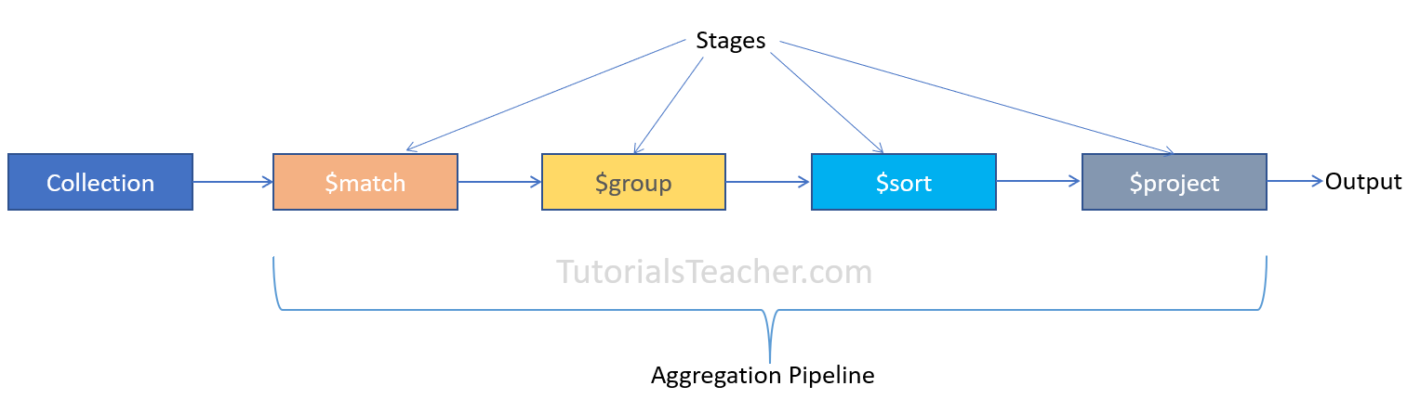
Let's see how to use different stages on the following employees collection.
Sample Data
Copy
db.employees.insertMany([
{
_id:1,
firstName: "John",
lastName: "King",
gender:'male',
email: "john.king@abc.com",
salary: 5000,
department: {
"name":"HR"
}
},
{
_id:2,
firstName: "Sachin",
lastName: "T",
gender:'male',
email: "sachin.t@abc.com",
salary: 8000,
department: {
"name":"Finance"
}
},
{
_id:3,
firstName: "James",
lastName: "Bond",
gender:'male',
email: "jamesb@abc.com",
salary: 7500,
department: {
"name":"Marketing"
}
},
{
_id:4,
firstName: "Rosy",
lastName: "Brown",
gender:'female',
email: "rosyb@abc.com",
salary: 5000,
department: {
"name":"HR"
}

},
{
_id:5,
firstName: "Kapil",
lastName: "D",
gender:'male',
email: "kapil.d@abc.com",
salary: 4500,
department: {
"name":"Finance"
}

},
{
_id:6,
firstName: "Amitabh",
lastName: "B",
gender:'male',
email: "amitabh.b@abc.com",
salary: 7000,
department: {
"name":"Marketing"
}
}
])

$match Stage
The $match stage is usually the first stage to select only the matching documents from a collection. It is equivalent to the Find() method. The following example demonstrates an aggregation pipeline with a single $match stage.
Example: $match Stage
Copy
db.employees.aggregate([ {$match:{ gender: 'female'}} ])
In the above example, the $match stage is specified as a document {$match:{ gender: 'female'}} in an array. It will return all documents where gender:'female' filed.
Output
[
{
_id: 4,
firstName: 'Rosy',
lastName: 'Brown',
gender: 'female',
email: 'rosyb@abc.com',
salary: 5000,
department: { name: 'HR' }
}
]
The $match stage in the aggregate() method gives the same output as the find() method. The db.persons.find({ gender: 'female' }) would return the same data as above.

$group Stage
Use the $group stage to group the input documents by the specified _id expression and returns a single document containing the accumulated values for each distinct group. Consider the following example.
Example: $group Stage
Copy
db.employees.aggregate([
{ $group:{ _id:'$department.name'} }
])
Output
[ { _id: 'Marketing' }, { _id: 'HR' }, { _id: 'Finance' } ]
In the above example, only the $group stage is specified in the pipeline array. The $group uses _id field to calculate the accumulated values for all the input documents as a whole. The expression { _id:'$department.name'} creates the distinct group on the field $department.name. Since we don't calculate any accumulated values, it returns the distinct values of $department.name, as shown below.
Now, let's calculate the accumulated values for each group. The following calculates the number of employees in each department.
Example: Get Accumulated Values
Copy

Output
[
{ _id: 'Marketing', totalEmployees: 2 },
{ _id: 'HR', totalEmployees: 2 },
{ _id: 'Finance', totalEmployees: 2 }
]
In the above example, we create distinct groups using _id:'$department.name' expression. In the second expression totalEmployees: { $sum:1 }, the totalEmployees is a field that will be included in the output, and { $sum:1 } is an accumulator expression where $sum is an Accumulator Operator that returns a sum of numerical values. Here, { $sum:1 } adds 1 for each document that falls under the same group.
The following aggregation pipeline contains two stages.
Example: $match and $group
Copy
db.employees.aggregate([
{ $match:{ gender:'male'}},
{ $group:{ _id:'$department.name', totalEmployees: { $sum:1 } }
}])
Output
[
{ _id: 'Marketing', totalEmployees: 2 },
{ _id: 'HR', totalEmployees: 1 },
{ _id: 'Finance', totalEmployees: 2 }
]
In the above example, the first stage selects all male employees and passes them as input to the second stage $group as an input. So, the output calculates the sum of all male employees.
The following calculates the sum of salaries of all male employees in the same department.
Example: Get Sum of Fields
Copy
db.employees.aggregate([
{ $match:{ gender:'male'}},
{ $group:{ _id:{ deptName:'$department.name'}, totalSalaries: { $sum:'$salary'} }
}])
Output
[
{ _id: 'Finance', totalSalaries: 12500 },
{ _id: 'HR', totalSalaries: 10000 },
{ _id: 'Marketing', totalSalaries: 14500 }
]
In the above example, { $match:{ gender:'male'}} returns all male employees. In the $group stage, an accumulator expression totalSalaries: { $sum:'$salary'} sums up numeric field salary and include it as totalSalaries in the output for each group.

$sort Stage
The $sort stage is used to sort the documents based on the specified field in ascending or descending order. The following sorts all male employees.
Example: Sort Documents
Copy
db.employees.aggregate([
{ $match:{ gender:'male'}},
{ $sort:{ firstName:1}}
])
Output
[
{
_id: 6,
firstName: 'Amitabh',
lastName: 'B',
gender: 'male',
email: 'amitabh.b@abc.com',
salary: 7000,
department: { name: 'Marketing' }
},
{
_id: 3,
firstName: 'James',
lastName: 'Bond',
gender: 'male',
email: 'jamesb@abc.com',
salary: 7500,
department: { name: 'Marketing' }
},
{
_id: 1,
firstName: 'John',
lastName: 'King',
gender: 'male',
email: 'john.king@abc.com',
salary: 5000,
department: { name: 'HR' }
},
{
_id: 5,
firstName: 'Kapil',
lastName: 'D',
gender: 'male',
email: 'kapil.d@abc.com',
salary: 4500,
department: { name: 'Finance' }
},
{
_id: 2,
firstName: 'Sachin',
lastName: 'T',
gender: 'male',
email: 'sachin.t@abc.com',
salary: 8000,
department: { name: 'Finance' }
}
]
In the above example, the $match stage returns all the male employees and passes it to the next stage $sort. The { $sort:{ firstName:1}} expression sorts the input documents by the firstName field in ascending order. 1 indicates the ascending order and -1 indicates descending order.
The following pipeline contains three stages to sort the groupped documents.
Example: Sort Groupped Data
Copy
db.employees.aggregate([
{ $match:{ gender:'male'}},
{ $group:{ _id:{ deptName:'$department.name'}, totalEmployees: { $sum:1} } },
{ $sort:{ deptName:1}}
])
Output
[
{ _id: { deptName: 'Finance' }, totalEmployees: 2 },
{ _id: { deptName: 'HR' }, totalEmployees: 1 },
{ _id: { deptName: 'Marketing' }, totalEmployees: 2 }
]
Thus, you can use the aggregation pipeline to get the required documents from the collection.

